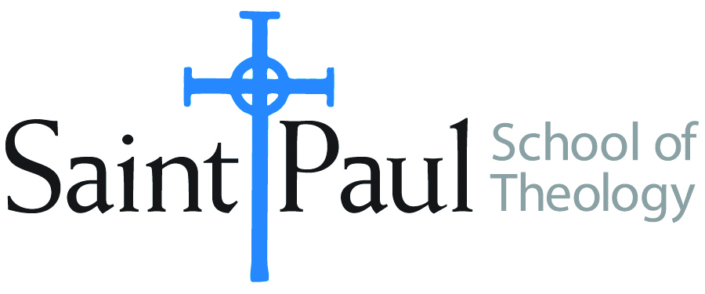**COURSE TEXTBOOK LIST INFORMATION**

|  |  |  |  |  |
| --- | --- | --- | --- | --- |
| ***FACULTY INSTRUCTIONS*** | |  | ***STUDENT INSTRUCTIONS*** | |
| *For each semester taught, faculty should complete and submit a new form each time the course is taught and returned. Forms are due by the first day of registration for a given term.*  ***DESKCOPY*** *– ordered by faculty and adjuncts USING THE* ***SAINT PAUL******AMAZON*** *ACCOUNT AND SPST CREDIT CARD. (OR, have Jennifer Smith order for you) at a $200 max for 1st time use of text per course.  IF you purchase yourself, note that we will NOT reimburse you for any tax or shipping paid by you, use the Expense Reimbursement Form, attach all actual / delivered receipt or invoices, return via email or mail, and this should be reimbursed with your first stipend payment (or next payroll payment)* | |  | *Students may acquire textbooks by ordering online via Amazon or other book retailer and having books shipped to them. Regardless of shopping / ordering method, students may check Cokesbury online for discount on text and certain texts may be sent free delivery.* | |
| **COURSE INSTRUCTOR(s)** | Melissa Tubbs Loya | | |  |
| **COURSE NUMBER & SECTION(s)** | HBS 301 ON | | |  |
| **COURSE NAME** | Introduction to Hebrew Bible | | |  |
| **COURSE SEMESTER & YEAR** | Fall 2025 | | |  |
| **DATE OF SUBMISSION** | 4.18.25 | | |  |

|  |  |  |  |  |  |  |
| --- | --- | --- | --- | --- | --- | --- |
| **REQUIRED TEXTBOOKS LIST**  BOOK TITLE *and* EDITION  *(include subtitle if applicable)* | | AUTHOR(S) | # of pages *to be read* | PUBLISHER *and* DATE | *13-Digit* ISBN | LIST PRICE  *(est)* |
| 1 | *The Old Testament*  *A Historical and Literary Introduction to the Hebrew Scriptures:* Fifth Edition | Michael D. Coogan and Cynthia R. Chapman | 616 | Oxford University Press, 2025 | 9780197768174 | $104.99 print; $84.99 ebook |
| 2 | **ONE of the following study Bibles (an older edition of any of these versions is also fine):**  *The New Oxford Annotated Bible, New Revised Standard Version, with the Apocrypha*, College  Edition  **OR**  *The New Interpreter's Study Bible: New Revised Standard Version with the Apocrypha.*  Nashville  **OR**  *HarperCollins Study Bible: Fully Revised & Updated: New Revised Standard Version: With the Apocryphal Deuterocanonical Books: Student Edition.* | Michael D. Coogan, and Marc Z. Brettler, eds.  Walter J. Harrelson, ed  Edited by Harold W. Attridge | 300–400 | Oxford University Press, 2010  Abingdon Press, 2003  HarperCollins, 2006 | 9780195289602  9780687278329  9780060786854 | $23.  $30.  $20 |
|  | **TOTAL** *Number of Pages to Be Read* | | 1016 |  | | |

|  |  |  |  |  |  |  |  |
| --- | --- | --- | --- | --- | --- | --- | --- |
| **RECOMMENDED TEXTBOOKS LIST**  BOOK TITLE *and* EDITION  *(include subtitle if applicable)* | | | AUTHOR(S) | # of pages *to be read* | PUBLISHER *and* DATE | *13-Digit* ISBN | LIST PRICE  *(est)* |
| 1 | *A Handbook to Old Testament Exegesis* | | William P. Brown | 380 | Westminster John Knox Press 2017 | 9780664259938 | $35 |
| 2 | *What They Don't Tell You: A Survivor's Guide to Biblical Studies* | | Michael Joseph Brown | 174 | Westminster John Knox 2000 (the revised version is also acceptable) | 9780664222208 | $4.17 (used on Amazon) |
|  | | **TOTAL** *Number of Pages to Be Read* | | 554 |  | | |

Will there be **additional readings**, articles, websites for students to complete on the moodle course page? **__x_YES ___No**