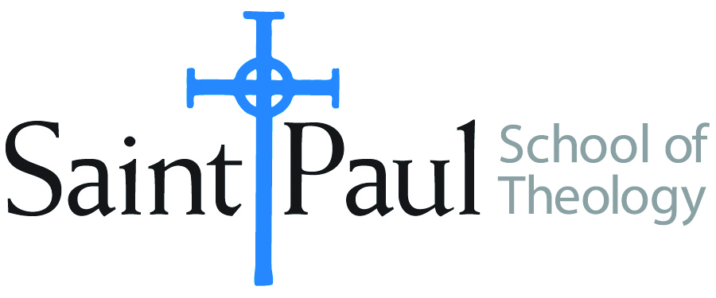**COURSE TEXTBOOK LIST INFORMATION**

|  |  |  |  |  |
| --- | --- | --- | --- | --- |
| **FACULTY INSTRUCTIONS** | |  | ***STUDENT INSTRUCTIONS***  ***(Both Campuses)*** | |
| For each semester taught, faculty should complete and submit a new form each time the course is taught and returned. Forms are due by the first day of registration for a given term. DESKCOPY – ordered by faculty and adjuncts at a $200 max for 1st time use of text per course.  Please fill out an Expense Reimbursement Form, attach all actual/delivered receipts, return via email or mail, and this should be reimbursed with your first stipend payment (or next payroll payment) | |  | *Students may acquire textbooks by ordering online via Amazon or other book retailer and having books shipped to them. Regardless of shopping / ordering method, students may check Cokesbury online for discount on text and certain texts may be sent free delivery.* | |
| **COURSE INSTRUCTOR(S)** | Richard Liantonio | | |  |
| **COURSE NUMBER & SECTION** | HBS 320 SO | | |  |
| **COURSE NAME** | Introduction to Biblical Hebrew | | |  |
| **COURSE SEMESTER & YEAR** | Fall 2025 | | |  |
| **DATE OF SUBMISSION** | 3/27/25 | | |  |

|  |  |  |  |  |  |  |  |
| --- | --- | --- | --- | --- | --- | --- | --- |
| |  | | --- | | **REQUIRED TEXTBOOKS LIST** |   **BOOK TITLE** *and* **EDITION**  *(include subtitle if applicable)* | | **AUTHOR(S)** | # of **PAGES** *to be read* | **PUBLISHER** *and* **DATE** | *13-Digit* **ISBN**  *(without dashes)* | **LIST PRICE**  *(est)* |
| 1 | *Aleph With Beth* | Bethany and Andrew Case | NA | <https://www.youtube.com/playlist?list=PLq1vmb-z7PpQt2PDNUr7XOzBjWAOWf0Rt> | **NA** | Free |
| 2 | *Learn Biblical Hebrew*, Second Edition | John H. Dobson | 300 | Baker | **978-0801097423** | $36.00 |
| 3 | *Biblical Hebrew Laminated Sheet* (Zondervan Get an A! Study Guides) | Gary D. Pratico, Miles V. Van Pelt | 4 | Zondervan Academic | **978-0310262954** | $11.99 |
| 4 | *Biblical Hebrew: A Compact Guide:* Second Edition | Miles V. Van Pelt |  | Zondervan Academic | **978-0310093787** | $19.56 |
|  | **TOTAL** *Number of Pages to Be Read* | |  |

|  |  |  |  |  |  |  |  |  |
| --- | --- | --- | --- | --- | --- | --- | --- | --- |
| |  | | --- | | **RECOMMENDED TEXTBOOKS LIST** |   **BOOK TITLE** *and* **EDITION**  *(include subtitle if applicable)* | | | **AUTHOR(S)** | # of **PAGES** *to be read* | **PUBLISHER** *and* **DATE** | *13-Digit* **ISBN**  *(without dashes)* | **LIST PRICE**  *(est)* |
| 1 | | *A Biblical Hebrew Reference Grammar:* Second Edition | Christo H. van der Merwe, Jacobus A. Naudé |  | T&T Clark | 978-0567663337 | $49.95 |
| 2 | | *Biblia Hebraica Stuttgartensia: A Reader's Edition (Hebrew Edition)* | Donald A. Vance, George Athas |  | Hendrickson | 978-1598563429 or  978-1598567496 | $55.95 |
|  |  | | |  |