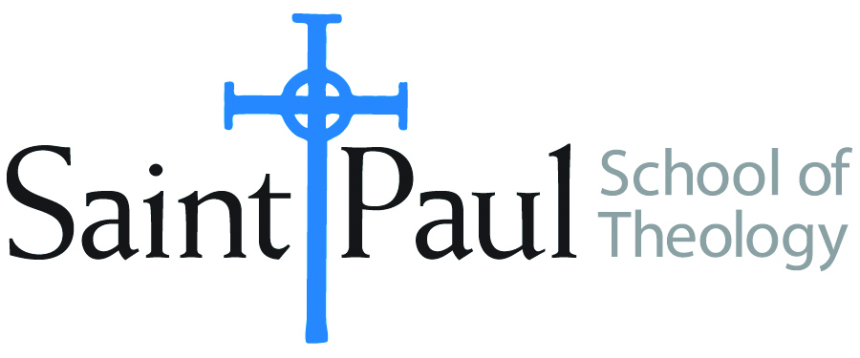
COURSE TEXTBOOK LIST INFORMATION
FACULTY INSTRUCTIONS |  |  | STUDENT INSTRUCTIONS
For each semester taught, faculty should complete and submit a new form each time the course is taught and returned. Forms are due by the first day of registration for a given term.  DESKCOPY – ordered by faculty and adjuncts USING THE SAINT PAUL AMAZON ACCOUNT AND SPST CREDIT CARD. (OR, have Jennifer Smith order for you) at a $200 max for 1st time use of text per course. IF you purchase yourself, note that we will NOT reimburse you for any tax or shipping paid by you, use the Expense Reimbursement Form, attach all actual / delivered receipt or invoices, return via email or mail, and this should be reimbursed with your first stipend payment (or next payroll payment) |  |  | Students may acquire textbooks by ordering online via Amazon or other book retailer and having books shipped to them. Regardless of shopping / ordering method, students may check Cokesbury online for discount on text and certain texts may be sent free delivery. Also check the SPST Library.
COURSE INSTRUCTOR(s) | Casey Sigmon
COURSE NUMBER & SECTION(s) | WOR 415 SO
COURSE NAME | Designing & Leading Worship
COURSE SEMESTER & YEAR | Fall 2024
DATE OF SUBMISSION | March 15, 2024

REQUIRED TEXTBOOKS LIST  BOOK TITLE and EDITION  (include subtitle if applicable) |  | AUTHOR(S) | # of pages to be read | PUBLISHER and DATE | 13-Digit ISBN | LIST PRICE  (est)
1 | The Art of Curating Worship: Reshaping the Role of Worship Leader | Mark Pierson | 250 | Fortress Press, 2010 | 978-1451400847 | 13.83
2 | The Abingdon Worship Annual 2024 | Mary Scifres | 150 | Abingdon Press, 2023 | 978-1791027049 | 25.43
3
4
5
 | TOTAL Number of Pages to Be Read |  | 250

RECOMMENDED TEXTBOOKS LIST  BOOK TITLE and EDITION  (include subtitle if applicable) |  |  | AUTHOR(S) | # of pages to be read | PUBLISHER and DATE | 13-Digit ISBN | LIST PRICE  (est)
1
2
3
4
 |  | TOTAL Number of Pages to Be Read

