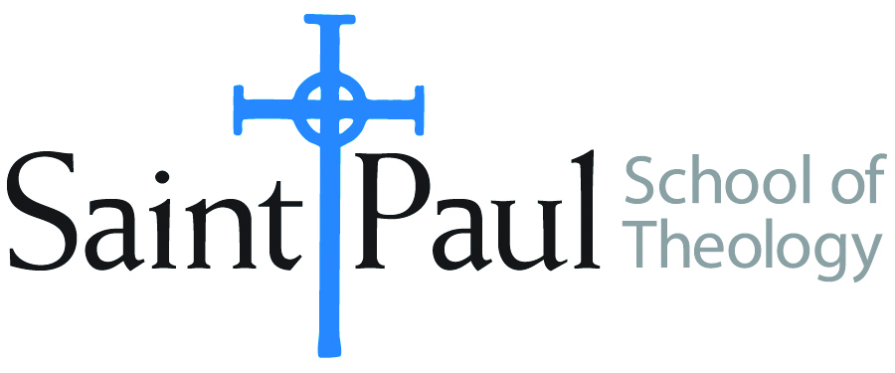
COURSE TEXTBOOK LIST INFORMATION
FACULTY INSTRUCTIONS |  |  | STUDENT INSTRUCTIONS
For each semester taught, faculty should complete and submit a new form each time the course is taught and returned. Forms are due by the first day of registration for a given term.  DESKCOPY – ordered by faculty and adjuncts USING THE SAINT PAUL AMAZON ACCOUNT AND SPST CREDIT CARD. (OR, have Jennifer Smith order for you) at a $200 max for 1st time use of text per course. IF you purchase yourself, note that we will NOT reimburse you for any tax or shipping paid by you, use the Expense Reimbursement Form, attach all actual / delivered receipt or invoices, return via email or mail, and this should be reimbursed with your first stipend payment (or next payroll payment) |  |  | Students may acquire textbooks by ordering online via Amazon or other book retailer and having books shipped to them. Regardless of shopping / ordering method, students may check Cokesbury online for discount on text and certain texts may be sent free delivery. Also check the SPST Library.
COURSE INSTRUCTOR(s) | Casey Sigmon
COURSE NUMBER & SECTION(s) | WOR 310 OKC/KS/SO
COURSE NAME | Choreographing the Movement of God’s Kindom Come
COURSE SEMESTER & YEAR | Fall 2024
DATE OF SUBMISSION | March 15, 2024

REQUIRED TEXTBOOKS LIST  BOOK TITLE and EDITION  (include subtitle if applicable) |  | AUTHOR(S) | # of pages to be read | PUBLISHER and DATE | 13-Digit ISBN | LIST PRICE  (est)
1 | Baptism, Eucharist, and Ministry | World Council of Churches | 30 | WCC 1982 | 978-2825407097 | 5.00
2 | Black Liturgies: Prayers, Poems, and Meditations for Staying Human | Cole Arthur Riley | 330 | Convergent Books, 2024 | 978-0593593646 | 18.49
3 | Worship for the Whole People of God: Vital Worship for the 21st Century. 2nd Edition | Ruth Duck | 300 | Westminster John Knox Press, 2021 | 978-0664264765 | 28.88
4 | Think Like a Filmmaker: Sensory-Rich Worship Design for Unforgettable Messages | Marcia McFee | 285 | Trokay Press, 2016 | 978-0997497809 | 29.99
5 | Practice the Pause: Jesus’ Contemplative Practice, New Brain Science, and What It Means to be Fully Human | Caroline Oakes | 300 | Broadleaf Books, 2023 | 978-1506483078 | 16.99
6 | The Synaptic Gospel: Teaching the Brain to Worship | Christopher D. Rodkey | 100 | University Press of America, 2012 | 978-0761857860 | 39.99
 | TOTAL Number of Pages to Be Read |  | 1,345

RECOMMENDED TEXTBOOKS LIST  BOOK TITLE and EDITION  (include subtitle if applicable) |  | AUTHOR(S) | # of pages to be read | PUBLISHER and DATE | 13-Digit ISBN | LIST PRICE  (est)
1 | A Womanist Theology of Worship: Liturgy, Justice, and Communal Righteousness | Lisa Allen |  | Orbis, 2021 | 978-1626984448 | 19.59
2 | Resources in the Ancient Church for Today’s Worship | Catherine Gunsalus González |  | Abingdon,2014 | 978-1426795657 | 19.64
3 | Christian Worship: 100,000 Sundays of Symbols and Rituals | Gail Ramshaw |  | Augsburg Fortress, 2009 | 978-0800662332 | 60.69
4 | Caesar and the Sacrament, Baptism: A Rite of Resistance | R. Alan Street |  | Cascade, 2018 | 978-1498228428 | 27

