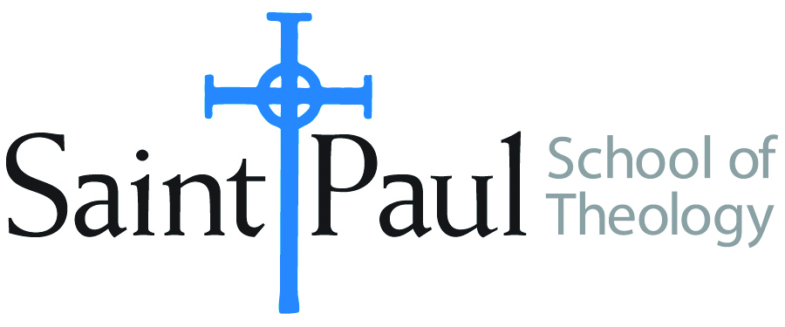
COURSE TEXTBOOK LIST INFORMATION
FACULTY INSTRUCTIONS |  |  | STUDENT INSTRUCTIONS
For each semester taught, faculty should complete and submit a new form each time the course is taught and returned. Forms are due by the first day of registration for a given term.  DESKCOPY – ordered by faculty and adjuncts USING THE SAINT PAUL AMAZON ACCOUNT AND SPST CREDIT CARD. (OR, have Jennifer Smith order for you) at a $200 max for 1st time use of text per course. IF you purchase yourself, note that we will NOT reimburse you for any tax or shipping paid by you, use the Expense Reimbursement Form, attach all actual / delivered receipt or invoices, return via email or mail, and this should be reimbursed with your first stipend payment (or next payroll payment) |  |  | Students may acquire textbooks by ordering online via Amazon or other book retailer and having books shipped to them. Regardless of shopping / ordering method, students may check Cokesbury online for discount on text and certain texts may be sent free delivery. Also check the SPST Library.
COURSE INSTRUCTOR(s) | Dr. Kristen Kvam
COURSE NUMBER & SECTION(s) | THL 422 ON
COURSE NAME | Seminars in Theological Study III: Christ and Salvation
COURSE SEMESTER & YEAR | Fall, 2024
DATE OF SUBMISSION | March 15, 2024

REQUIRED TEXTBOOKS LIST  BOOK TITLE and EDITION  (include subtitle if applicable) |  | AUTHOR(S) | # of pages to be read | PUBLISHER and DATE | 13-Digit ISBN | LIST PRICE  (est)
1 | Bible, Any Translation
2 | Cur Deus Homo (Why the God Human) [often bundled with Proslogium and other texts as in Deane’s Saint Anselm: Basic Writings or Fairweather’s A Scholastic Miscellany | Anselm of Canterbury | 116 |  |  | $6.00 used
3 | Knowing Christ Crucified: The Witness of African American Religious Experience | Copeland, M. Shawn | 176 | Orbis: 2018 | 9781626982987 | $11.00 used
4 | Jesus Wept: The Significance of Jesus’ Laments in the New Testament | Eklund, Rebekah | 172 | Bloomsbury: 2015 | 9780567671820 | $34.00 from Bloomsbury; 45.00 used.
5 | Consider Jesus: New Waves of Renewal in Christology | Johnson, Elizabeth A. | 150 | Crossroads: 1990 | 9780824511616 | $4.00 used
6 | Jesus the Savior: The Meaning of Jesus Christ for Christian Faith | Placher, William C. | 221 | Westminster: 2001 | 9780664223915 | $4.00 used
 | TOTAL Number of Pages to Be Read |  | 835

RECOMMENDED TEXTBOOKS LIST  BOOK TITLE and EDITION  (include subtitle if applicable) |  | AUTHOR(S) | # of pages to be read | PUBLISHER and DATE | 13-Digit ISBN | LIST PRICE  (est)
1 | Christus Victor | Aulen, Gustav |  | New York: Macmillan, 1969
2 | Readings in Christian Theology | Hodgson, Peter and Robert King |  | Philadelphia: Fortress Press, 1985
3 | The Cross: History, Art, and Controversy. | Jensen, Robin M. |  | Massachusetts: Harvard University Press, 2017
4 | Constructive Theology: A Contemporary Approach to Classical Themes | Jones, Serene and Paul Lakeland |  | Minneapolis: Fortress Press, 2005
5 | Creeds of the Churches: A Reader of Christian Doctrine from the Bible to Present, Revised Edition | Leith, John H. |  | Atlanta: John Knox Press, 1973
6 | Handbook of Christian Theology, New and Enlarged | Musser, Donald and Joseph Price |  | Nashville: Abingdon Press, 2003
7 | Narratives of a Vulnerable God: Christ, Theology, and Scripture | Placher, William C. |  | Louisville: Westminster John Knox, 1994
8 | Belonging to God: A Commentary on a Brief Statement of Faith | Placher, William C. and David Willis-Watkins |  | Louisville: Westminster John Knox, 1992
9 | Dictionary of Feminist Theologies | Russell, Letty and J. Shannon Clarkson |  | Louisville: Westminster John Knox, 2004
 | TOTAL Number of Pages to Be Read

