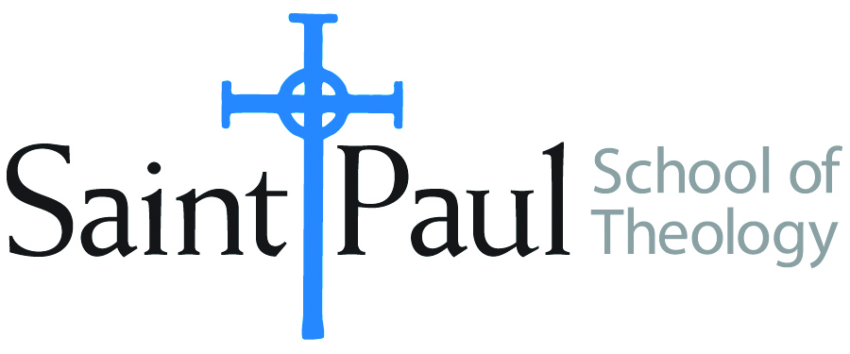
COURSE TEXTBOOK LIST INFORMATION
FACULTY INSTRUCTIONS |  |  | STUDENT INSTRUCTIONS
For each semester taught, faculty should complete and submit a new form each time the course is taught and returned. Forms are due by the first day of registration for a given term.  DESKCOPY – ordered by faculty and adjuncts at a $200 max for 1st time use of text per course. Please fill out an Expense Reimbursement Form, attach all actual / delivered receipt or invoices, return via email or mail, and this should be reimbursed with your first stipend payment (or next payroll payment) |  |  | Students may acquire textbooks by ordering online via Amazon or other book retailer and having books shipped to them. Regardless of shopping / ordering method, students may check Cokesbury online for discount on text and certain texts may be sent free delivery.
COURSE INSTRUCTOR(s) | Rev. Tino Herrera
COURSE NUMBER & SECTION(s) | SFR 301
COURSE NAME | Spiritual Formation – What Makes You Come Alive: A Day With Howard Thurman
COURSE SEMESTER & YEAR | Fall 2024
DATE OF SUBMISSION | 3/25/2024

REQUIRED TEXTBOOKS LIST  BOOK TITLE and EDITION  (include subtitle if applicable) |  | AUTHOR(S) | # of pages to be read | PUBLISHER and DATE | 13-Digit ISBN | LIST PRICE  (est)
1 | Anchored in the Current: Discovering Howard Thurman as Educator, Activist, Guide, and Prophet | Ellison II, Gregory C. | 176 | Westminster John Knox Press; Louisville, KY 2020 | 978-0664260668 | 20.00
2
3
4
5
 | TOTAL Number of Pages to Be Read

RECOMMENDED TEXTBOOKS LIST  BOOK TITLE and EDITION  (include subtitle if applicable) |  |  | AUTHOR(S) | # of pages to be read | PUBLISHER and DATE | 13-Digit ISBN | LIST PRICE  (est)
1
2
3
4
 |  | TOTAL Number of Pages to Be Read

