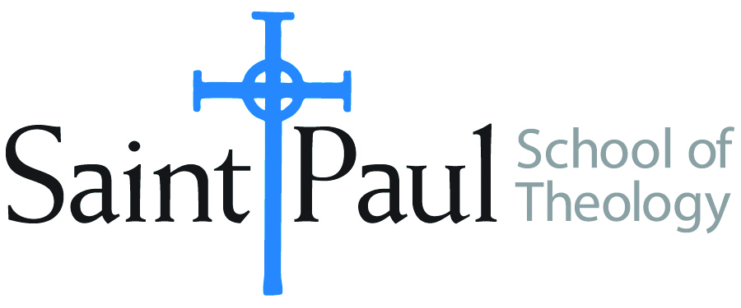
COURSE TEXTBOOK LIST INFORMATION

FACULTY INSTRUCTIONS |  |  | STUDENT INSTRUCTIONS  (Both Campuses)
For each semester taught, faculty should complete and submit a new form each time the course is taught and returned. Forms are due by the first day of registration for a given term.  DESKCOPY – ordered by faculty and adjuncts at a $200 max for 1st time use of text per course. Please fill out an Expense Reimbursement Form, attach all actual/delivered receipts, return via email or mail, and this should be reimbursed with your first stipend payment (or next payroll payment) |  |  | Students may acquire textbooks by ordering online via Amazon or other book retailer and having books shipped to them. Regardless of shopping / ordering method, students may check Cokesbury online for discount on text and certain texts may be sent free delivery.
COURSE INSTRUCTOR(S) | Richard Liantonio
COURSE NUMBER & SECTION | HBS 301
COURSE NAME | Introduction to Hebrew Bible
COURSE SEMESTER & YEAR | Fall 2024
DATE OF SUBMISSION

REQUIRED TEXTBOOKS LIST  BOOK TITLE and EDITION  (include subtitle if applicable) |  | AUTHOR(S) | # of PAGES to be read | PUBLISHER and DATE | 13-Digit ISBN  (without dashes) | LIST PRICE  (est)
1 | The Old Testament  A Historical and Literary  Introduction to the Hebrew  Scriptures: Fourth Edition | Michael D.  Coogan and  Cynthia R.  Chapman | 608 | Oxford  University  Press, 2017 | 9780190608651 | $76.95
2 | The New Oxford Annotated Bible,  New Revised Standard Version, with  the Apocrypha, Fifth edition | Michael D. Coogan, et. al. | 100 | Oxford  University  Press, 2018 | 978-0190276072 | $39.99
3 | What They Don't Tell You: A  Survivor's Guide to Biblical Studies, Second Edition | Michael Joseph  Brown | 176 | Westminster John Knox | 978-0664235949 | $16.99**
4 | Ancient Near Eastern Thought and the Old Testament: Introducing the Conceptual World of the Hebrew Bible, Second Edition | John H. Walton | 384 | Baker Academic | 978-1540960214 | $17.93
5
6
7
8
 | TOTAL Number of Pages to Be Read |  | 1268

**Book is out of print, but can be bought as an e-book or check here for used versions at https://www.addall.com
RECOMMENDED TEXTBOOKS LIST  BOOK TITLE and EDITION  (include subtitle if applicable) |  |  | AUTHOR(S) | # of PAGES to be read | PUBLISHER and DATE | 13-Digit ISBN  (without dashes) | LIST PRICE  (est)
1 |  | The Hebrew Bible: Feminist and Intersectional Perspectives | Gale A. Yee (Editor) |  | Fortress | 978-1506425481 | 19.00
2 |  | Womanist Midrash: A Reintroduction to the Women of the Torah and the Throne | Wilda C. Gafney |  | Westminster John Knox | 978-0664239039 | 23.49 (available on Audible)
3 |  | The Hebrew Bible: A Translation with Commentary | Robert Alter |  | W.W. Norton | 978-0664239039 | 75.99 (available on Audible)
4 |  | The Queer Bible Commentary | Robert Shore-Goss and Mona West (eds.) |  | SCM Press | 978-0334060789 | 91.01
5 |  | Africa Bible Commentary: A One-Volume Commentary Written by 70 African Scholars | Tokunboh Adeyemo (ed.) |  | Zondervan | 978-0310291879 | 31.49
6 |  | Women's Bible Commentary, Third Edition: Revised and Updated | Carol A. Newson et. al (eds.) |  | Westminster John Knox | 978-0664237073 | 55.00
7 |  | How to Read the Bible | James L. Kugel |  | Free Press | 978-0743235877 | 23.75 (available on Audible)

