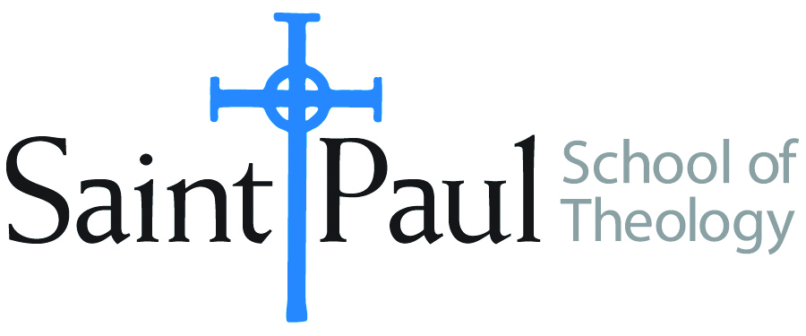
COURSE TEXTBOOK LIST INFORMATION
FACULTY INSTRUCTIONS |  |  | STUDENT INSTRUCTIONS
For each semester taught, faculty should complete and submit a new form each time the course is taught and returned. Forms are due by the first day of registration for a given term.  DESKCOPY – ordered by faculty and adjuncts USING THE SAINT PAUL AMAZON ACCOUNT AND SPST CREDIT CARD. (OR, have Jennifer Smith order for you) at a $200 max for 1st time use of text per course. IF you purchase yourself, note that we will NOT reimburse you for any tax or shipping paid by you, use the Expense Reimbursement Form, attach all actual / delivered receipt or invoices, return via email or mail, and this should be reimbursed with your first stipend payment (or next payroll payment) |  |  | Students may acquire textbooks by ordering online via Amazon or other book retailer and having books shipped to them. Regardless of shopping / ordering method, students may check Cokesbury online for discount on text and certain texts may be sent free delivery. Also check the SPST Library.
COURSE INSTRUCTOR(s) | Dr. Kristen E. Kvam
COURSE NUMBER & SECTION(s) | EWR 313 CAM and SO
COURSE NAME | Engaging World Religions: People of the Book
COURSE SEMESTER & YEAR | Fall, 2024
DATE OF SUBMISSION | 03/15/2024

REQUIRED TEXTBOOKS LIST  BOOK TITLE and EDITION  (include subtitle if applicable) |  | AUTHOR(S) | # of pages to be read | PUBLISHER and DATE | 13-Digit ISBN | LIST PRICE  (est)
1 | Bible, any translation
2 | Living Traditions of the Bible: Scripture in Jewish, Christian, and Muslim Practice | Bowley, James | All | Chalice Press, 1999 | 9780827221277 | 6.00 used
3 | The Qur’an | M.A.S. Abdel Haleen, ed. | 100 | Oxford World Classics, 2008 | 9780199535958 | 7.50 used
4 | “The Issue of Woman-Man Equality in the Islamic Tradition” in Eve and Adam: Jewish, Christian, and Muslim Readings on Genesis and Gender | Kvam, Schearing, and Ziegler, eds. | 13 | Indiana University Press, 1999 | 9780253212719 | 8.00 used
5 | Heirs of Abraham: The Future of Muslim, Jewish, and Christian Relations | Hinze and Omar, eds. | All | Wipf and Stock, 2013 | 9781620327609 | 14.00 used
6 | The Faith Club: A Muslim, a Christian, A Jew – Three Women Search for Understanding | Idilby, Oliver, and Warner | All | Atria Books, 2007 | 9780743290487 | 8.00 used
7 | Hagar, Sarah, and Their Children: Jewish, Christian, and Muslim Perspectives | Trible and Russell, eds. | All | Westminster John Knox, 2006 | 9780664228825 | 8.00 used
 | TOTAL Number of Pages to Be Read |  | 1000

RECOMMENDED TEXTBOOKS LIST  BOOK TITLE and EDITION  (include subtitle if applicable) |  | AUTHOR(S) | # of pages to be read | PUBLISHER and DATE | 13-Digit ISBN | LIST PRICE  (est)
1 | Your God, My God, Our God: Rethinking Christian Theology for Religious Plurality | Ariarajah, S. Wesley |  | WCC Publications: 2012
2 | Shared Stories, Rival Tellings: Early Encounters of Jews, Christians, and Muslims | Gregg, Robert C |  | Oxford University Press, 2015
3 | Feminist Edges of the Qur’an | Hidayatullah, Aysha |  | Oxford, 2014
4 | The Bible Tells Me So: Uses and Abuses of Holy Scripture | Hill, Jim, and Rand Cheadle |  | Anchor Books, 1996
5 | Honoring our Neighbor’s Faith | Farlee, Robert Buckley ed. |  | Minneapolis: Augsburg Fortress, 1999
5 | Families of Faith: An Introduction to World Religions for Christians | Martinson, Paul V. |  | Fortress, 1999
6 | Interreligious Relations and the Church: Key Study Guides(missional, moral, theological, ecumenical, identity) | National Council of Churches of Christ in the USA |  | www.nationalcouncilofchurches
7 | Three Faiths, One God: The Formative Faith and Practice of Judaism, Christianity, and Islam | Neusner, Jacob, and Bruce Chilton |  | Brill, 2003
8 | Faith and Feminism: Ecumenical Essays | Trible and Lipsett, eds. |  | Westminster John Knox, Nov. 2014
9 | Christianity and Plurality: Classic and Contemporary Readings | Plantinga, Richard |  | London: Wiley-Blackwell, 1999
 | TOTAL Number of Pages to Be Read

