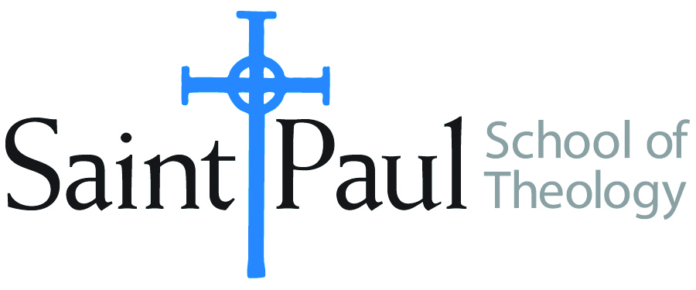
COURSE TEXTBOOK LIST INFORMATION
FACULTY INSTRUCTIONS |  |  | STUDENT INSTRUCTIONS
For each semester taught, faculty should complete and submit a new form each time the course is taught and returned. Forms are due by the first day of registration for a given term.  DESKCOPY – ordered by faculty and adjuncts at a $200 max for 1st time use of text per course. Please fill out an Expense Reimbursement Form, attach all actual / delivered receipt or invoices, return via email or mail, and this should be reimbursed with your first stipend payment (or next payroll payment) |  |  | Students may acquire textbooks by ordering online via Amazon or other book retailer and having books shipped to them. Regardless of shopping / ordering method, students may check Cokesbury online for discount on text and certain texts may be sent free delivery.  Kindle versions of texts are acceptable in this course.
COURSE INSTRUCTOR(s) | Nancy Howell and Joshua Bartholomew
COURSE NUMBER & SECTION(s) | DMIN 510 HYB/FW
COURSE NAME | Orienting Seminar
COURSE SEMESTER & YEAR | Fall 2024
DATE OF SUBMISSION | March 15, 2024

REQUIRED TEXTBOOKS LIST  BOOK TITLE and EDITION  (include subtitle if applicable) |  | AUTHOR(S) | # of pages to be read | PUBLISHER and DATE | 13-Digit ISBN | LIST PRICE  (est)
1 | Mining the Motherlode: Methods in Womanist Ethics | Floyd-Thomas,  Stacy M. | 206 | Pilgrim Press, 2006 | 978-0829815849 | $22.02
2 | Contemporary Theology: An Introduction | MacGregor | 416 | SCM Press, 2018 | 9780310113720 | $31
3 | Quality Research Papers: A Multi-Methods Approach to Projects for Doctor of Ministry Theses | Sensing, Tim | About 200 of 300 | Wipf & Stock, 2011 | 9781610972765 | $35
4 | A Manual for Writers of Research Papers, Theses, and Dissertations, 9th ed. | Turabian, Kate L. | About 100 of 300 | Zondervan Academic, 2019 | 9780226430577 | $15
5 | Quality Research Papers: For Students of Religion and Theology, 3rd ed. | Vyhmeister, Nancy Jean, and Terry Dwain Robertson | About 100 of 304 | Zondervan Academic, 2011 | 9780310514022 | $25
 | TOTAL Number of Pages to Be Read

RECOMMENDED TEXTBOOKS LIST  BOOK TITLE and EDITION  (include subtitle if applicable) |  |  | AUTHOR(S) | # of pages to be read | PUBLISHER and DATE | 13-Digit ISBN | LIST PRICE  (est)
1 | Theological Reflection Methods, 2nd ed. |  | Graham, Elaine |  | SCM Press, 2019 | 978-0334056119 | $21,75
 |  | TOTAL Number of Pages to Be Read

