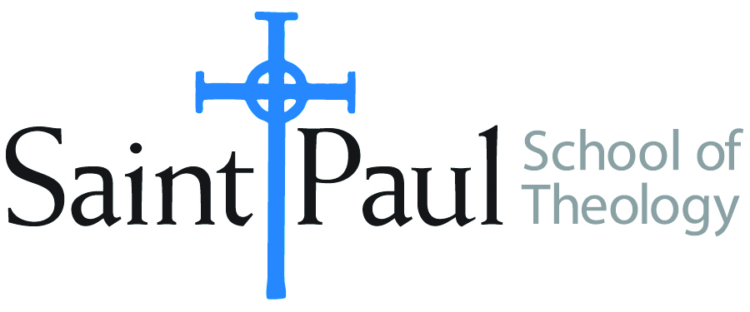
COURSE TEXTBOOK LIST INFORMATION
FACULTY INSTRUCTIONS |  |  | STUDENT INSTRUCTIONS
For each semester taught, faculty should complete and submit a new form each time the course is taught and returned. Forms are due by the first day of registration for a given term.  DESKCOPY – ordered by faculty and adjuncts USING THE SAINT PAUL AMAZON ACCOUNT AND SPST CREDIT CARD. (OR, have Jennifer Smith order for you) at a $200 max for 1st time use of text per course. IF you purchase yourself, note that we will NOT reimburse you for any tax or shipping paid by you, use the Expense Reimbursement Form, attach all actual / delivered receipt or invoices, return via email or mail, and this should be reimbursed with your first stipend payment (or next payroll payment) |  |  | Students may acquire textbooks by ordering online via Amazon or other book retailer and having books shipped to them. Regardless of shopping / ordering method, students may check Cokesbury online for discount on text and certain texts may be sent free delivery.
COURSE INSTRUCTOR(s) | Kris Kvam
COURSE NUMBER & SECTION(s) | THL 445
COURSE NAME | Theology, Feminism, and the Psalms
COURSE SEMESTER & YEAR | Spring, 2024
DATE OF SUBMISSION | October 20, 2023

REQUIRED TEXTBOOKS LIST  BOOK TITLE and EDITION  (include subtitle if applicable) |  | AUTHOR(S) | # of pages to be read | PUBLISHER and DATE | 13-Digit ISBN | LIST PRICE  (est)
1 | The Book of Psalms: A Translation with Commentary | Alter, Robert | 130 | WW Norton, 2007 | 9780393337044 | $7.83*
2 | Psalms, Books 4-5, Wisdom Commentary Series | deClaisse-Walford, Nancy | 230 | Liturgical Press, | 9780814681213 | $56
3 | Journey Through the Psalms, Revised and Expanded | Hopkins, Denise Dombkowski | 175 | Chalice, 2002 | 9780827217140 | $6.35
4 | Psalms: Chalice Commentaries for Today | Steussy, Marti J. | 210 | Chalice, 2004 | 9780827205260 | $16.63
5 | Bible – any translation; variety valued
 | TOTAL Number of Pages to Be Read |  | +/- 875

RECOMMENDED TEXTBOOKS LIST  BOOK TITLE and EDITION  (include subtitle if applicable) |  | AUTHOR(S) | # of pages to be read | PUBLISHER and DATE | 13-Digit ISBN | LIST PRICE  (est)
1 | The Women’s Bible Commentary, Revised and Updated, Third Edition | Newsom, Carol A. Sharon Ringe, and Jacqueline Lapsley, ed. |  | Westminster John Knox, 2012 | 9780664237073 | $32.03
2 | Feminist Biblical Interpretation: A Compendum of Critical Commentary… | Schottroff, Luise and Marie-Theres Wacker |  | Wm. B. Eerdmans, 2012 | 9780802860972 | $64.68
3 | Wisdom and Psalms: A Feminist Companion to the Bible (Second Series) | Brenner, Athalya, and Carole Fontaine |  | Sheffield Academic Press, 1998 | 9781850759171 | $15.21
4 | The Inclusive Psalms | Priests for Equality |  | Priests for Equality, 1997 | 9780964427921 | $4.13
5 | Psalms in Interpreting Biblical Texts series | Brown, William P. |  | WW Norton, 2010 | 9780687008452 | $19.60
6 | The Inclusive Bible: The First Egalitarian Translation |  |  | Rowan and Littlefield, 2007 | 9781580512138 | $20.65
*SPECIAL INSTRUCTIONS: Kris Kvam suggests the purchase of used books through websites such as ABEBooks.com, Thriftbooks.com or through Used Bookstores such as Steel’s Used Christian Books in Kansas city.
She will describe her reasons for recommending the foregoing texts so Students may want to wait to purchase from the Recommended list until They have Heard Kvam’s descriptions.

Additional Notes from Kris Kvam
1. The “Recommended books” are ones from which there will be a few short reading assignments. I am recommending them for purchase (or to put on a Gift list) as Ideas for building students’ professional libraries.
2. The last item in the Recommended list is an inclusive translation of the entire biblical canon. if someone purchases this, there would be no need to also purchase the inclusive psalms translation that is listed under required books.
3. Other Recommended Books will be described during Class Sessions.
4. Many course Readings will be articles and essays so are not on this book list.

