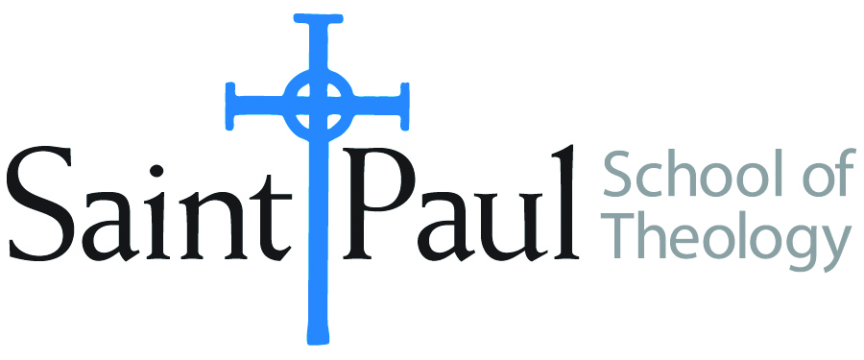
COURSE TEXTBOOK LIST INFORMATION
FACULTY INSTRUCTIONS |  |  | STUDENT INSTRUCTIONS
For each semester taught, faculty should complete and submit a new form each time the course is taught and returned. Forms are due by the first day of registration for a given term.  DESKCOPY – ordered by faculty and adjuncts USING THE SAINT PAUL AMAZON ACCOUNT AND SPST CREDIT CARD. (OR, have Jennifer Smith order for you) at a $200 max for 1st time use of text per course. IF you purchase yourself, note that we will NOT reimburse you for any tax or shipping paid by you, use the Expense Reimbursement Form, attach all actual / delivered receipt or invoices, return via email or mail, and this should be reimbursed with your first stipend payment (or next payroll payment) |  |  | Students may acquire textbooks by ordering online via Amazon or other book retailer and having books shipped to them. Regardless of shopping / ordering method, students may check Cokesbury online for discount on text and certain texts may be sent free delivery.
COURSE INSTRUCTOR(s) | Kris Kvam
COURSE NUMBER & SECTION(s) | THL 301: all sections
COURSE NAME | Introduction to Systematic Theology
COURSE SEMESTER & YEAR | Spring, 2024
DATE OF SUBMISSION | October 20, 2023

REQUIRED TEXTBOOKS LIST  BOOK TITLE and EDITION  (include subtitle if applicable) |  | AUTHOR(S) | # of pages to be read | PUBLISHER and DATE | 13-Digit ISBN | LIST PRICE  (est)
1 | The Humanity of God | Barth, Karl | 90 | WJK, 1960 | 9780804206129 | $4.00*
2 | Constructive Theology: A Contemporary Approach to Classical Themes | Jones, Serene and Paul Lakeland, ed. | 160 | Fortress Press, 2005 | 9780800636838 | $20.99
3 | Theological Worlds: Understanding the Alternative Rhythms of Christian Belief | Jones, W. Paul | 250 | Abingdon, 1989 | 9780687414703 | $5.96
4 | Why Study Theology? | Luck, Donald | 150 | Chalice, 1999 | 9780226803418 | $14.58
5 | Belonging to God: A Commentary on A Brief Statement of Faith | Placher, William, and David Willis-Watkins | 200 | WJK, 1992 | 9780664252960 | $5.72
6 | Awake to the Moment: An Introduction to Theology | Schneider, Laurel, and Stephen G. Ray, Jr., ed | 250 | WJK, 2016 | 9780664261887 | $9.06
7 | The Irrelevance and Relevance of the Christian Message | Tillich, Paul | Txt: 65; Intro: 20 | Pilgrim Press, 1996 | PP: 978022680341 | $3.00
 | TOTAL Number of Pages to Be Read |  | 1200

RECOMMENDED TEXTBOOKS LIST  BOOK TITLE and EDITION  (include subtitle if applicable) |  | AUTHOR(S) | # of pages to be read | PUBLISHER and DATE | 13-Digit ISBN | LIST PRICE  (est)
1 | Christian Confessions: A Historical Introduction | Campbell, Ted A. |  | Westminster John Knox, 1996 | 9780664256500 | $4.41
2 | Christian Thought Revisited: Three Types of Theology | Gonzalez, Justo |  | Orbis, 1999 | 978170752551 | 2.51
3 | Christian Doctrine, Revised Ed. | Guthrie, Shirley |  | Westminster John Knox, 1994 | 9780664253684 | 8.88
4 | Readings in Christian Theology | Hodgson, Peter, and Robert King, ed. |  | Fortress, 1985 | 9780800618490 | 4.74
5 | Quest for the Living God | Johnson, Elizabeth |  | Bloomsbury Academic, 2007 | 9780826417701 | 5.16
6 | Worlds Within a Congregation: Dealing with Theological Diversity | Jones, W. Paul |  | Abingdon Press, 2000 | 9780687084340 | 5.96
7 | The Concise Oxford Dictionary of the Christian Church | Livingston, E. A., ed. |  | Oxford University Pres, 2913 | 9780199659623 | 4.39
8 | Dictionary of the Ecumenical Movement. 1st or 2d Edition | Lossky, Nicholas, et. |  | Eerdmanns | varies | varies
9 | Westminster Dictionary of Theological Terms, 2d edition, rev. | McKim, Donald I. |  | Wetminster John Knox, 2014. | Pbk: 9780664238353 | 2.39
10 | New and Enlarged Handbook of Christian Theology | Musser, Donald, and Joseph Price |  | Abingdon, 2003 | 9780687091126 | 11.94
11 | Dictionary of Feminist Theologies | Russell, Letty, and Clarkson, J. Shannon |  | Westminster John Knox, 1996 | 9780664220587 | 6.65
12 | A Manual for Writers of Research Papers, Theses, and Dissertations, a recent edition | Turabian, Kate L., et alia |  | University of Chicago Press, | 9780226430577 | 4.14
*SPECIAL INSTRUCTIONS: Kris Kvam suggests the purchase of used books through websites such as ABEBooks.com, Thriftbooks.com or through Used Bookstores such as Steel’s Used Christian Books in Kansas city.
She will describe her reasons for recommending the foregoing texts so Students may want to wait to purchase from the Recommended list until They have Heard Kvam’s descriptions.

