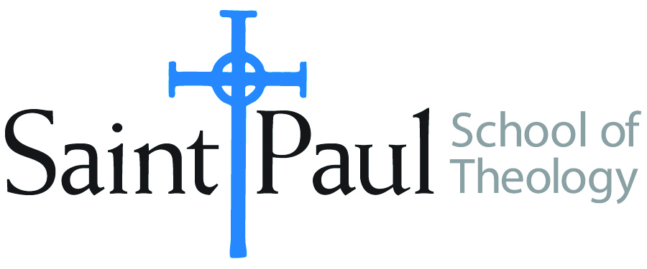
COURSE TEXTBOOK LIST INFORMATION
FACULTY INSTRUCTIONS |  |  | STUDENT INSTRUCTIONS
For each semester taught, faculty should complete and submit a new form each time the course is taught and returned. Forms are due by the first day of registration for a given term.  DESKCOPY – ordered by faculty and adjuncts USING THE SAINT PAUL AMAZON ACCOUNT AND SPST CREDIT CARD. (OR, have Jennifer Smith order for you) at a $200 max for 1st time use of text per course. IF you purchase yourself, note that we will NOT reimburse you for any tax or shipping paid by you, use the Expense Reimbursement Form, attach all actual / delivered receipt or invoices, return via email or mail, and this should be reimbursed with your first stipend payment (or next payroll payment) |  |  | Students may acquire textbooks by ordering online via Amazon or other book retailer and having books shipped to them. Regardless of shopping / ordering method, students may check Cokesbury online for discount on text and certain texts may be sent free delivery.
COURSE INSTRUCTOR(s) | Amy Oden
COURSE NUMBER & SECTION(s) | SFR 301
COURSE NAME | Spiritual Formation Retreat
COURSE SEMESTER & YEAR | Spring 2024
DATE OF SUBMISSION | 10-18-23

REQUIRED TEXTBOOKS LIST  BOOK TITLE and EDITION  (include subtitle if applicable) |  | AUTHOR(S) | # of pages to be read | PUBLISHER and DATE | 13-Digit ISBN | LIST PRICE  (est)
1 | Right Here, Right Now: The Practice of Christian Mindfulness | Amy Oden | 112 | Abingdon, 2017 | 9781501832499 | 14.99
2
3
4
5
 | TOTAL Number of Pages to Be Read

RECOMMENDED TEXTBOOKS LIST  BOOK TITLE and EDITION  (include subtitle if applicable) |  |  | AUTHOR(S) | # of pages to be read | PUBLISHER and DATE | 13-Digit ISBN | LIST PRICE  (est)
1
2
3
4
 |  | TOTAL Number of Pages to Be Read

