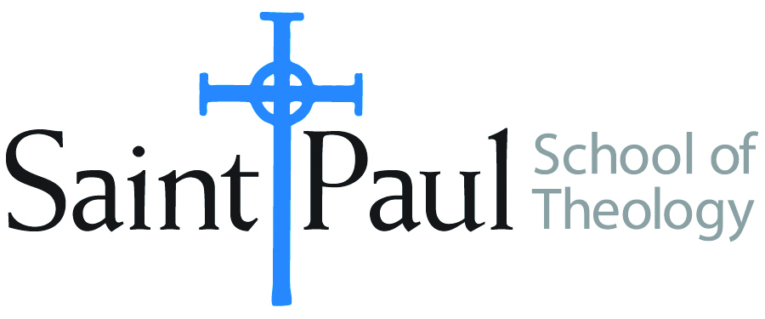
COURSE TEXTBOOK LIST INFORMATION
FACULTY INSTRUCTIONS |  |  | STUDENT INSTRUCTIONS
For each semester taught, faculty should complete and submit a new form each time the course is taught and returned. Forms are due by the first day of registration for a given term.  DESKCOPY – ordered by faculty and adjuncts USING THE SAINT PAUL AMAZON ACCOUNT AND SPST CREDIT CARD. (OR, have Jennifer Smith order for you) at a $200 max for 1st time use of text per course. IF you purchase yourself, note that we will NOT reimburse you for any tax or shipping paid by you, use the Expense Reimbursement Form, attach all actual / delivered receipt or invoices, return via email or mail, and this should be reimbursed with your first stipend payment (or next payroll payment) |  |  | Students may acquire textbooks by ordering online via Amazon or other book retailer and having books shipped to them. Regardless of shopping / ordering method, students may check Cokesbury online for discount on text and certain texts may be sent free delivery.
COURSE INSTRUCTOR(s) | Kris Kvam
COURSE NUMBER & SECTION(s) | MIN 340 and MIN 341
COURSE NAME | Women, Society, and Church Studies Seminar
COURSE SEMESTER & YEAR | Spring, 2024
DATE OF SUBMISSION | October 20, 2023

REQUIRED TEXTBOOKS LIST  BOOK TITLE and EDITION  (include subtitle if applicable) |  | AUTHOR(S) | # of pages to be read | PUBLISHER and DATE | 13-Digit ISBN | LIST PRICE  (est)
1 | She: Five Keys to Unlock the Power of Women in Ministry | Lewis, Karoline M. | 220 | Abingdon, 2016 | 9781501842696 | $6.28*
2 | Embody: Five Keys to Leading with Integrity | Lewis, Karoline M. | 85 | Abingdon, 2020 | 9781501899423 | $13.35
3 | Feminist Theory and Christian Theology: Cartographies of Grace (Guides to Theological Inquiry | Jones, Serene | 50 | Fortress Press, 2000 | 9780800626945 | $6.35
 | TOTAL Number of Pages to Be Read |  | 355

RECOMMENDED TEXTBOOKS LIST  BOOK TITLE and EDITION  (include subtitle if applicable) |  | AUTHOR(S) | # of pages to be read | PUBLISHER and DATE | 13-Digit ISBN | LIST PRICE  (est)
1 | Glass Walls: Shattering the Six Gender Bias Barriers Still Holding Women Back at Work | Diehl, Amy, and Leanne Dzubinski |  | Rowman and Littlefield, 2023. | 9781538170960 | $22.04
2 | Participant Workbook for She | Lewis, Karoline M. |  | Abingdon, 2017 | 9781501842696 | $6.28
3 | Dictionary of Feminist Theologies | Russell, Letty, and Shannon Clarkson |  | WJK, 1996 | 9780664220587 | $6.14
*SPECIAL INSTRUCTIONS: Kris Kvam suggests the purchase of used books through websites such as ABEBooks.com, Thriftbooks.com or through Used Bookstores such as Steel’s Used Christian Books in Kansas city.
She will describe her reasons for recommending the foregoing texts so Students may want to wait to purchase from the Recommended list until They have Heard Kvam’s descriptions.

