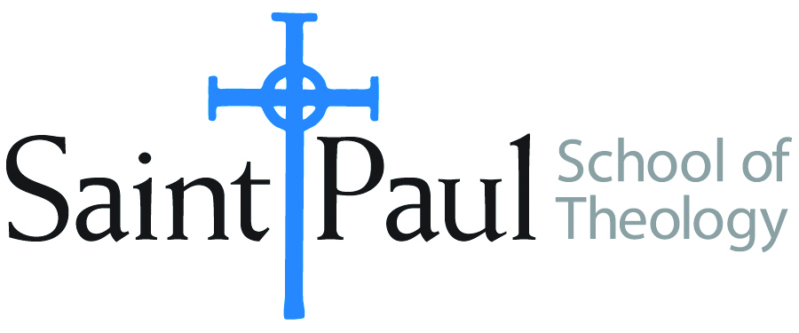
COURSE TEXTBOOK LIST INFORMATION
FACULTY INSTRUCTIONS |  |  | STUDENT INSTRUCTIONS
For each semester taught, faculty should complete and submit a new form each time the course is taught and returned. Forms are due by the first day of registration for a given term.  DESKCOPY – ordered by faculty and adjuncts at a $200 max for 1st time use of text per course. Please fill out an Expense Reimbursement Form, attach all actual / delivered receipt or invoices, return via email or mail, and this should be reimbursed with your first stipend payment (or next payroll payment) |  |  | Students may acquire textbooks by ordering online via Amazon or other book retailer and having books shipped to them. Regardless of shopping / ordering method, students may check Cokesbury online for discount on text and certain texts may be sent free delivery.
COURSE INSTRUCTOR(s) | Hal Knight
COURSE NUMBER & SECTION(s) | HST 474
COURSE NAME | Early American Methodism
COURSE SEMESTER & YEAR | Spring 2024
DATE OF SUBMISSION | 10-11-23

REQUIRED TEXTBOOKS LIST  BOOK TITLE and EDITION  (include subtitle if applicable) |  | AUTHOR(S) | # of pages to be read | PUBLISHER and DATE | 13-Digit ISBN | LIST PRICE  (est)
1 | The Democratization of American Christianity | Nathan O. Hatch | 217 | Yale, 1991 | 9780300050608 | $29
2 | The Methodists and Revolutionary America | Dee E. Andrews | 242 | Princeton, 2002 | 9780691092980 | $53
3 | American Saint | John H. Wigger | 418 | Oxford, 2009 | 978019948246 | $46
4 | Methodist and Pietist | J. Steven O’Malley & Jason E. Vickers | 97 | Abingdon, 2011 | 9781426714351 | $48
5 | A Will to Choose | J. Gordon Melton | 283 | Rowman & Littlefield, 2007 | 9780742552647 | $52
6 | The Beauty of Holiness | Charles Edward White | 236 | Wipf & Stock | 9781556358012 | $28
7 | Respectable Methodism | Daniel F. Flores | 158 | Wipf & Stock | 9781666713951 | $31
 | TOTAL Number of Pages to Be Read |  | 1651

