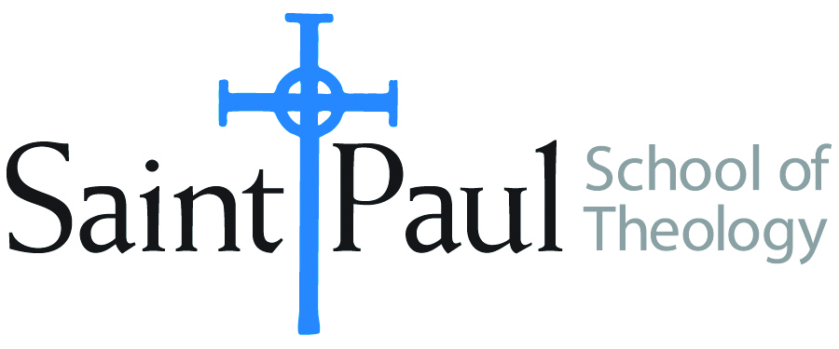
COURSE TEXTBOOK LIST INFORMATION
FACULTY INSTRUCTIONS |  |  | STUDENT INSTRUCTIONS
For each semester taught, faculty should complete and submit a new form each time the course is taught and returned. Forms are due by the first day of registration for a given term.  DESKCOPY – ordered by faculty and adjuncts at a $200 max for 1st time use of text per course. Please fill out an Expense Reimbursement Form, attach all actual / delivered receipt or invoices, return via email or mail, and this should be reimbursed with your first stipend payment (or next payroll payment) |  |  | Students may acquire textbooks by ordering online via Amazon or other book retailer and having books shipped to them. Regardless of shopping / ordering method, students may check Cokesbury online for discount on text and certain texts may be sent free delivery.
COURSE INSTRUCTOR(s) | Lisa Wolfe
COURSE NUMBER & SECTION(s) | HBS 423 HYB FW
COURSE NAME | Wisdom Literature
COURSE SEMESTER & YEAR | SPRING 2024
DATE OF SUBMISSION | 03/09/23

REQUIRED TEXTBOOKS LIST  BOOK TITLE and EDITION  (include subtitle if applicable) |  | AUTHOR(S) | # of pages to be read | PUBLISHER and DATE | 13-Digit ISBN | LIST PRICE  (est)
1 | Wisdom Commentary: Qoheleth (Ecclesiastes) | Wolfe, Lisa | 243 | Liturgical Press, 2000 | ISBN: 9780814681237, 8123  eISBN: 9780814681480, E8148 | $50
2 | Wisdom Commentary: Proverbs | Ogden Bellis, Alice | 273 | Liturgical Press, 2018 | ISBN: 9780814681220, 8122  eISBN: 9780814681473, E8147 | $50
3 | New Interpreter’s Bible Vol. IV: Introduction to Hebrew Poetry; Job; Psalms (select) | Leander Keck, Ed. | 387 | Abingdon, 1996 | ISBN-10 ‏ : ‎ 9780687278176  ISBN-13 ‏ : ‎ 978-0687278176 | $70 (available on Ministry Matters)
4 | New Interpreter’s Bible Vol. V: Introduction to Wisdom Literature; Wisdom; Sirach | Leander Keck, Ed. | 450 | Abingdon, 1997 | 0-687-27818-X | $120 (available on Ministry Matters)
5 | Israel’s Wisdom Literature: A Liberation-Critical Reading | Bergant, Dianne | 191 | Fortress, 1997 | 0-8006-2875-6 | $25
 | TOTAL Number of Pages to Be Read

RECOMMENDED TEXTBOOKS LIST  BOOK TITLE and EDITION  (include subtitle if applicable) |  |  | AUTHOR(S) | # of pages to be read | PUBLISHER and DATE | 13-Digit ISBN | LIST PRICE  (est)
1 | Abingdon Old Testament Commentaries: Ecclesiastes |  | Duncan, Julie | 195 | Abingdon, 2017 | 978-1-5018-3757-9 | $24
2
 |  | TOTAL Number of Pages to Be Read

