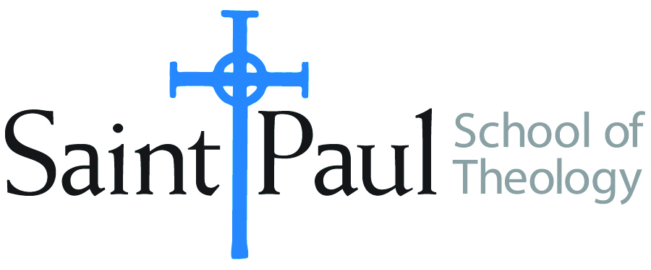
COURSE TEXTBOOK LIST INFORMATION

FACULTY INSTRUCTIONS |  |  | STUDENT INSTRUCTIONS  (Both Campuses)
For each semester taught, faculty should complete and submit a new form each time the course is taught and returned. Forms are due by the first day of registration for a given term.  DESKCOPY – ordered by faculty and adjuncts at a $200 max for 1st time use of text per course. Please fill out an Expense Reimbursement Form, attach all actual/delivered receipts, return via email or mail, and this should be reimbursed with your first stipend payment (or next payroll payment) |  |  | Students may acquire textbooks by ordering online via Amazon or other book retailer and having books shipped to them. Regardless of shopping / ordering method, students may check Cokesbury online for discount on text and certain texts may be sent free delivery.
COURSE INSTRUCTOR(S) | Hal Knight
COURSE NUMBER & SECTION | THL 422
COURSE NAME | The Holy Spirit: Seminar in Theological Studies III
COURSE SEMESTER & YEAR | Summer 2023
DATE OF SUBMISSION | 3/3/23

REQUIRED TEXTBOOKS LIST  BOOK TITLE and EDITION  (include subtitle if applicable) |  | AUTHOR(S) | # of PAGES to be read | PUBLISHER and DATE | 13-Digit ISBN  (without dashes) | LIST PRICE  (est)
1 | Flame of Love (Second Edition) | Clark H. Pinnock | 286 | InterVarsity 2022 | 978514001301 | $24
2 | The Holy Spirit and Liberation | Jose Comblin | 186 | Wipf and Stock 2004 | ‎9781592445622 | $31
3 | Spirit of God | Jeffrey W. Barbeau & Beth Felker Jones | 229 | InterVarsity 2015 | 9780830824649 | $4 (new & used copies available)
4
5
 | TOTAL Number of Pages to Be Read |  | 701

RECOMMENDED TEXTBOOKS LIST  BOOK TITLE and EDITION  (include subtitle if applicable) |  |  | AUTHOR(S) | # of PAGES to be read | PUBLISHER and DATE | 13-Digit ISBN  (without dashes) | LIST PRICE  (est)
1
2
3
4

