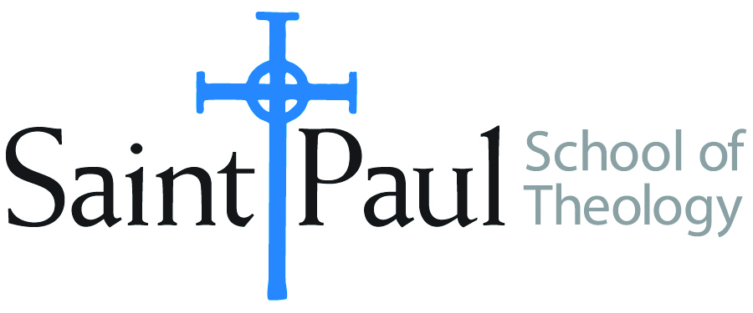
COURSE TEXTBOOK LIST INFORMATION

FACULTY INSTRUCTIONS |  |  | STUDENT INSTRUCTIONS  (Both Campuses)
For each semester taught, faculty should complete and submit a new form each time the course is taught and returned. Forms are due by the first day of registration for a given term.  DESKCOPY – ordered by faculty and adjuncts at a $200 max for 1st time use of text per course. Please fill out an Expense Reimbursement Form, attach all actual/delivered receipts, return via email or mail, and this should be reimbursed with your first stipend payment (or next payroll payment) |  |  | Students may acquire textbooks by ordering online via Amazon or other book retailer and having books shipped to them. Regardless of shopping / ordering method, students may check Cokesbury online for discount on text and certain texts may be sent free delivery.
COURSE INSTRUCTOR(S) | Robinson
COURSE NUMBER & SECTION | MIN 301 CAM/KS CAM/OK SO
COURSE NAME | Introduction to Ministry
COURSE SEMESTER & YEAR | Fall 2023
DATE OF SUBMISSION | March 3, 2023

REQUIRED TEXTBOOKS LIST  BOOK TITLE and EDITION  (include subtitle if applicable) |  | AUTHOR(S) | # of PAGES to be read | PUBLISHER and DATE | 13-Digit ISBN  (without dashes) | LIST PRICE  (est)
1 | Exploring Practices of Ministry | Cooper-White and Cooper-White | 120 | Fortress, 2014 | 9781451488937 | $19
2 | The Color of Compromise | Tisby, Jamar | 225 | Zondervan, 2020 | 9780310113607 | $15
3 | How to Think Theologically, 3rd ed. | Stone/Duke | 130 | Fortress, 2013 | 9780800699321 | $14
4 | Soul Feast, newly revised ed. | Thompson, Marjorie | 165 | WJKP, 2014 | 9780664239244 | $13.50
5 | Covenants and Care | Harbaugh, et al | 150 | Fortress, 1998 | 9780800629885 | $18
6 | The Way of the Heart | Nouwen | 112 | Random House, 2003 | 9780345463357 | $14
 | TOTAL Number of Pages to Be Read |  | 750

RECOMMENDED TEXTBOOKS LIST  BOOK TITLE and EDITION  (include subtitle if applicable) |  |  | AUTHOR(S) | # of PAGES to be read | PUBLISHER and DATE | 13-Digit ISBN  (without dashes) | LIST PRICE  (est)
1 |  | Wild Mercy | Starr, M | 40 | Sounds True, 2019 | 9781683641568 | $15
2
3
4

