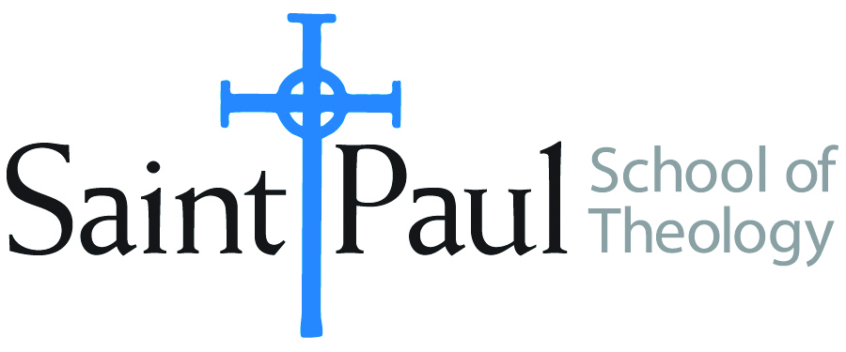
COURSE TEXTBOOK LIST INFORMATION

FACULTY INSTRUCTIONS |  |  | STUDENT INSTRUCTIONS  (Both Campuses)
For each semester taught, faculty should complete and submit a new form each time the course is taught and returned. Forms are due by the first day of registration for a given term.  DESKCOPY – ordered by faculty and adjuncts at a $200 max for 1st time use of text per course. Please fill out an Expense Reimbursement Form, attach all actual/delivered receipts, return via email or mail, and this should be reimbursed with your first stipend payment (or next payroll payment) |  |  | Students may acquire textbooks by ordering online via Amazon or other book retailer and having books shipped to them. Regardless of shopping / ordering method, students may check Cokesbury online for discount on text and certain texts may be sent free delivery.
COURSE INSTRUCTOR(S) | Lee Webb
COURSE NUMBER & SECTION | MIN 231
COURSE NAME | Information Literacy in Theological Education
COURSE SEMESTER & YEAR | Fall 2023
DATE OF SUBMISSION | March 3, 2023

REQUIRED TEXTBOOKS LIST  BOOK TITLE and EDITION  (include subtitle if applicable) |  | AUTHOR(S) | # of PAGES to be read | PUBLISHER and DATE | 13-Digit ISBN  (without dashes) | LIST PRICE  (est)
1 | Quality Research Papers, 4th ed. | Vyhmeister & Robertson | 300 | Zondervan, 2020 | 9780310106661 | 26.99
2
3
4
5
 | TOTAL Number of Pages to Be Read |  | 300

RECOMMENDED TEXTBOOKS LIST  BOOK TITLE and EDITION  (include subtitle if applicable) |  |  | AUTHOR(S) | # of PAGES to be read | PUBLISHER and DATE | 13-Digit ISBN  (without dashes) | LIST PRICE  (est)
1 |  | Writing Theology Well, 2nd ed. | Yaghjian | 60 | Bloomsbury, 2015 | 9780567499172 | 30.95
2
3
4
 |  |  |  | 60

