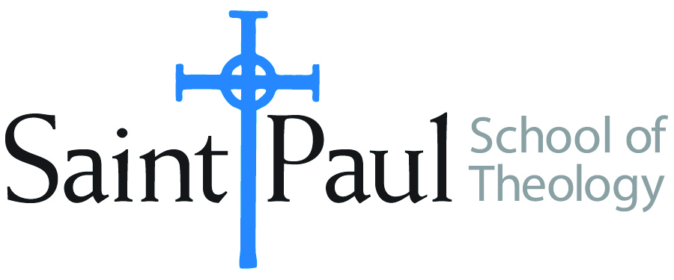
COURSE TEXTBOOK LIST INFORMATION
FACULTY INSTRUCTIONS |  |  | STUDENT INSTRUCTIONS
For each semester taught, faculty should complete and submit a new form each time the course is taught and returned. Forms are due by the first day of registration for a given term.  DESKCOPY – ordered by faculty and adjuncts at a $200 max for 1st time use of text per course. Please fill out an Expense Reimbursement Form, attach all actual / delivered receipt or invoices, return via email or mail, and this should be reimbursed with your first stipend payment (or next payroll payment) |  |  | Students may acquire textbooks by ordering online via Amazon or other book retailer and having books shipped to them. Regardless of shopping / ordering method, students may check Cokesbury online for discount on text and certain texts may be sent free delivery.
COURSE INSTRUCTOR(s) | Melissa Tubbs Loya
COURSE NUMBER & SECTION(s) | HBS 301 ON
COURSE NAME | Introduction to the Hebrew Bible
COURSE SEMESTER & YEAR | Fall 2023
DATE OF SUBMISSION | 3/16/23

