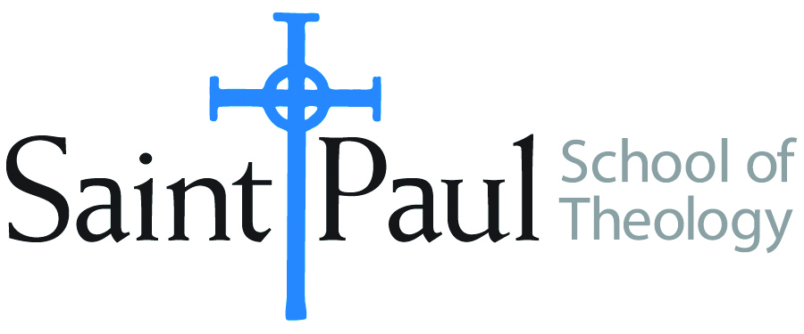
COURSE TEXTBOOK LIST INFORMATION

FACULTY INSTRUCTIONS |  |  | STUDENT INSTRUCTIONS  (Both Campuses)
For each semester taught, faculty should complete and submit a new form each time the course is taught and returned. Forms are due by the first day of registration for a given term.  DESKCOPY – ordered by faculty and adjuncts at a $200 max for 1st time use of text per course. Please fill out an Expense Reimbursement Form, attach all actual/delivered receipts, return via email or mail, and this should be reimbursed with your first stipend payment (or next payroll payment) |  |  | Students may acquire textbooks by ordering online via Amazon or other book retailer and having books shipped to them. Regardless of shopping / ordering method, students may check Cokesbury online for discount on text and certain texts may be sent free delivery.
COURSE INSTRUCTOR(S) | Hal Knight
COURSE NUMBER & SECTION | DST 313
COURSE NAME | John Wesley and the Movements of the Spirit
COURSE SEMESTER & YEAR | Fall 2023
DATE OF SUBMISSION | 3-4-23

REQUIRED TEXTBOOKS LIST  BOOK TITLE and EDITION  (include subtitle if applicable) |  | AUTHOR(S) | # of PAGES to be read | PUBLISHER and DATE | 13-Digit ISBN  (without dashes) | LIST PRICE  (est)
1 | John Wesley’s Sermons: An Anthology | Albert C. Outler/Richard P. Heitzenrater, eds | 267 | Abingdon 1991 | 9780687204953 | $19
2 | Responsible Grace* | Randy L. Maddox | 241 | Abingdon 1994 | 9780687003341 | $28
3 | The Theology of John Wesley* | Kenneth J. Collins | 331 | Abingdon 2007 | 9780687646333 | $25
4 | Anticipating Heaven Below | Henry H. Knight III | 250 | Wipf & Stock | 9781620329603 | $25
5 | From Aldersgate to Azusa Street | Henry H. Knight III | 364 | Wipf and Stock 2010 | 9781606089880 | $38
 | *Students will choose to read EITHER the Maddox or Collins book.  TOTAL Number of Pages to Be Read |  | 1122 or 1212

