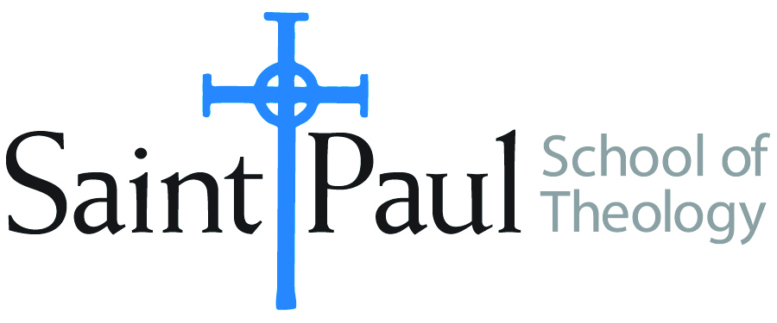
COURSE TEXTBOOK LIST INFORMATION
FACULTY INSTRUCTIONS |  |  | STUDENT INSTRUCTIONS
For each semester taught, faculty should complete and submit a new form each time the course is taught and returned. Forms are due by the first day of registration for a given term.  DESKCOPY – ordered by faculty and adjuncts at a $200 max for 1st time use of text per course. Please fill out an Expense Reimbursement Form, attach all actual / delivered receipt or invoices, return via email or mail, and this should be reimbursed with your first stipend payment (or next payroll payment) |  |  | Students may acquire textbooks by ordering online via Amazon or other book retailer and having books shipped to them. Regardless of shopping / ordering method, students may check Cokesbury online for discount on text and certain texts may be sent free delivery.
COURSE INSTRUCTOR(s) | Thomas Hoffmann
COURSE NUMBER & SECTION(s) | CHS 355 ON
COURSE NAME | Mission of the Church in the World
COURSE SEMESTER & YEAR | FALL 2023
DATE OF SUBMISSION | March 15, 2023

REQUIRED TEXTBOOKS LIST  BOOK TITLE and EDITION  (include subtitle if applicable) |  | AUTHOR(S) | # of pages to be read | PUBLISHER and DATE | 13-Digit ISBN | LIST PRICE  (est)
1 | Christian Mission: How Christianity Became a World Religion | Robert, Dana | 200 | Abingdon, 2012 | 9780631236207 | $30.00
2 | Intercultural Communication: A Peacebuilding Perspective | Remland, et al | 250 | Waveland press, 2013 | 9781478622055 | $60.00
3 | Mission: An Essential Guide | Cardoza-Orlando, Carlos F. | 100 | Abingdon, 2002 | 9780687054725 | $20.00
4
5
 | TOTAL Number of Pages to Be Read |  | 550

RECOMMENDED TEXTBOOKS LIST  BOOK TITLE and EDITION  (include subtitle if applicable) |  |  | AUTHOR(S) | # of pages to be read | PUBLISHER and DATE | 13-Digit ISBN | LIST PRICE  (est)
1 | Transforming Mission (20th Anniv. Ed.) |  | Bosch, David J. |  | Orbis, 2011 | 9781570759482 | $30.00
2 | Reader's Guide To Transforming Mission |  | Nussbaum, Stan |  | Orbis, 2005 | 9781570755941 | $12.00
3 | Missional Theology: An Introduction |  | Franke, John R. |  | Baker Acad., 2020 | 9780801036354 | $17.00
4 | Serving with Eyes Wide Open: Doing Short-Term Missions with Cultural Intelligence (Updated Edition) |  | Livermore, David |  | Baker Books, 2012 | 9780801015199 | $9.00
 |  | TOTAL Number of Pages to Be Read

