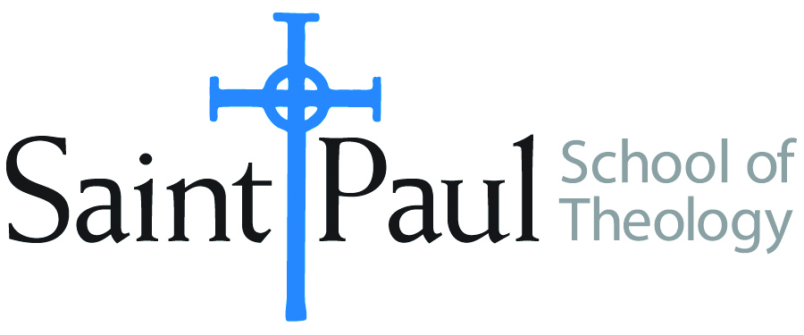
COURSE TEXTBOOK LIST INFORMATION

FACULTY INSTRUCTIONS |  |  | STUDENT INSTRUCTIONS  (Both Campuses)
For each semester taught, faculty should complete and submit a new form each time the course is taught and returned. Forms are due by the firstEe day of registration for a given term.  DESKCOPY – ordered by faculty and adjuncts at a $200 max for 1st time use of text per course. Please fill out an Expense Reimbursement Form, attach all actual/delivered receipts, return via email or mail, and this should be reimbursed with your first stipend payment (or next payroll payment) |  |  | Students may acquire textbooks by ordering online via Amazon or other book retailer and having books shipped to them. Regardless of shopping / ordering method, students may check Cokesbury online for discount on text and certain texts may be sent free delivery.
COURSE INSTRUCTOR(S) | Elaine Robinson
COURSE NUMBER & SECTION | CHL 520 HYB/FW
COURSE NAME | Becoming Agents of Hope
COURSE SEMESTER & YEAR | Fall 2023
DATE OF SUBMISSION | March 3, 2023

REQUIRED TEXTBOOKS LIST  BOOK TITLE and EDITION  (include subtitle if applicable) |  | AUTHOR(S) | # of PAGES to be read | PUBLISHER and DATE | 13-Digit ISBN  (without dashes) | LIST PRICE  (est)
1 | The New Parish | Sparks, Soerens, Friesen | 190 | IVP, 2014 | 9780830841158 | $20
2 | The Practice of Adaptive Leadership | Heifetz, Grashow, Linsky | 200 | Harvard Business Press, 2009 | 9781422105764 | $20
3 | Intercultural Church | Marzouk | 200 | Fortress, 2019 | 9781506433462 | $19
4 | Leading with Love | Robinson | 130 | Fortress, 2023 | TBD | TBD
5 | The Unbearable Wholeness of Being | Delio, Ilia | 200 | Orbis, 2020 | 9781626980297 | $26
 | TOTAL Number of Pages to Be Read |  | 920

RECOMMENDED TEXTBOOKS LIST  BOOK TITLE and EDITION  (include subtitle if applicable) |  |  | AUTHOR(S) | # of PAGES to be read | PUBLISHER and DATE | 13-Digit ISBN  (without dashes) | LIST PRICE  (est)
1
2
3
4
I

