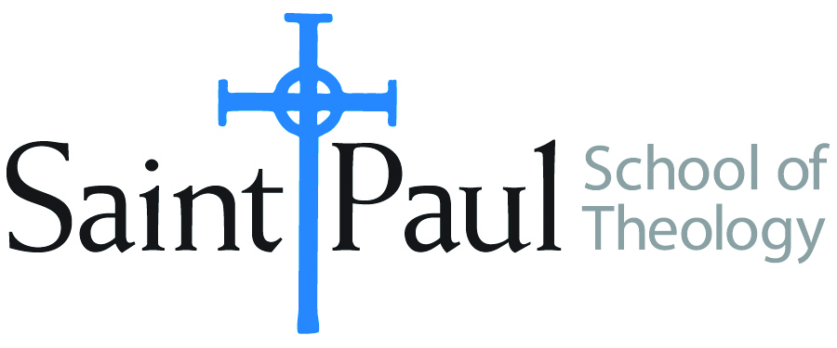
COURSE TEXTBOOK LIST INFORMATION

FACULTY INSTRUCTIONS |  |  | STUDENT INSTRUCTIONS  (Both Campuses)
For each semester taught, faculty should complete and submit a new form each time the course is taught and returned. Forms are due by the first day of registration for a given term.  DESKCOPY – ordered by faculty and adjuncts at a $200 max for 1st time use of text per course. Please fill out an Expense Reimbursement Form, attach all actual/delivered receipts, return via email or mail, and this should be reimbursed with your first stipend payment (or next payroll payment) |  |  | Students may acquire textbooks by ordering online via Amazon or other book retailer and having books shipped to them. Regardless of shopping / ordering method, students may check Cokesbury online for discount on text and certain texts may be sent free delivery.
COURSE INSTRUCTOR(S) | Laura Glover
COURSE NUMBER & SECTION | PCM 327 CAM FW
COURSE NAME | Ministry with Older Adults
COURSE SEMESTER & YEAR | Spring 2023
DATE OF SUBMISSION | November 23, 2022

REQUIRED TEXTBOOKS LIST  BOOK TITLE and EDITION  (include subtitle if applicable) |  | AUTHOR(S) | # of PAGES to be read | PUBLISHER and DATE | 13-Digit ISBN  (without dashes) | LIST PRICE  (est)
1 | From Dry Bones to Living Hope: Embracing God's Faithfulness in Late Life | Missy Buchanan | 160 | Upper Room Books, October 1, 2021 | 9780835819763 | $15.74
2
3
4
5
 | TOTAL Number of Pages to Be Read

RECOMMENDED TEXTBOOKS LIST  BOOK TITLE and EDITION  (include subtitle if applicable) |  |  | AUTHOR(S) | # of PAGES to be read | PUBLISHER and DATE | 13-Digit ISBN  (without dashes) | LIST PRICE  (est)
1
2
3
4

