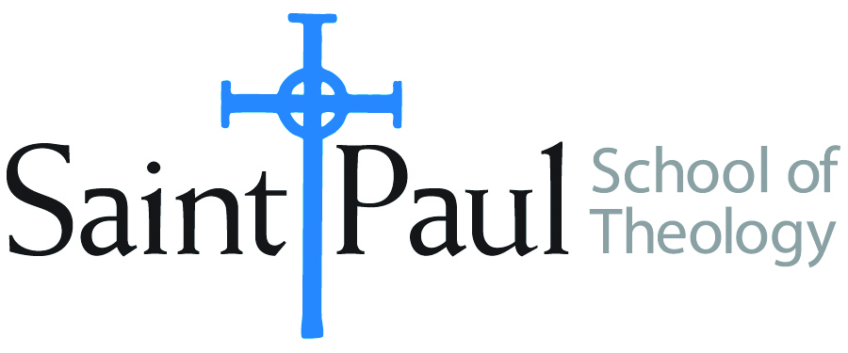
COURSE TEXTBOOK LIST INFORMATION

FACULTY INSTRUCTIONS |  |  | STUDENT INSTRUCTIONS  (Both Campuses)
For each semester taught, faculty should complete and submit a new form each time the course is taught and returned. Forms are due by the first day of registration for a given term.  DESKCOPY – ordered by faculty and adjuncts at a $200 max for 1st time use of text per course. Please fill out an Expense Reimbursement Form, attach all actual/delivered receipts, return via email or mail, and this should be reimbursed with your first stipend payment (or next payroll payment) |  |  | Students may acquire textbooks by ordering online via Amazon or other book retailer and having books shipped to them. Regardless of shopping / ordering method, students may check Cokesbury online for discount on text and certain texts may be sent free delivery.
COURSE INSTRUCTOR(S) | Joshua S. Bartholomew
COURSE NUMBER & SECTION | CHS 349
COURSE NAME | The Black Church in the U.S.A.
COURSE SEMESTER & YEAR | Spring 2023
DATE OF SUBMISSION

REQUIRED TEXTBOOKS LIST  BOOK TITLE and EDITION  (include subtitle if applicable) |  | AUTHOR(S) | # of PAGES to be read | PUBLISHER and DATE | 13-Digit ISBN  (without dashes) | LIST PRICE  (est)
1 | The Black Church in the African American Experience | C. Eric Lincoln and Lawrence H. Mamiya | 300 | Duke University Press, 1990 (2003) | 9780822310730 | $33
2 | Black Religion and Black Radicalism: An Interpretation of the Religious History of African Americans | Wilmore, Gayraud S. | 200 | Orbis Books, 1998 | 9781570751820 | $32
3 | Black Churches and Local Politics: Clergy Influence, Organizational Partnerships, and Civic Empowerment | Smith, Drew R. | 200 | Rowman and Littlefield Publishers, 2005 | 9780742545229 | $37
4 | Black Preaching: The Recovery of a Powerful Art | Mitchell, Henry H. | 120 | Abigndon Press, 1990 | 9780687036141 | $16
5 | What’s Faith Got to Do with It? Black Bodies/Christian Souls | Douglas, Kelly Brown | 220 | Orbis Books, 2005 | 9781570756092 | $21
 | TOTAL Number of Pages to Be Read

RECOMMENDED TEXTBOOKS LIST  BOOK TITLE and EDITION  (include subtitle if applicable) |  | AUTHOR(S) | # of PAGES to be read | PUBLISHER and DATE | 13-Digit ISBN  (without dashes) | LIST PRICE  (est)
1 | The Social Teachings of the Black Churches | Paris, Peter |  | Fortress Press, 1985 | 9780800618056 | $24
2 | A Black Theology of Liberation: 50th Anniversary Edition | Cone, James |  | Orbis Books, 2020 | 9781626983854 | $21
3 | Righteous Discontent: The Women’s Movement in the Black Baptist Church, 1880-1920 | Higginbotham, Evelyn Brooks |  | Harvard University Press, 1994 | 9780674769786 | $35

