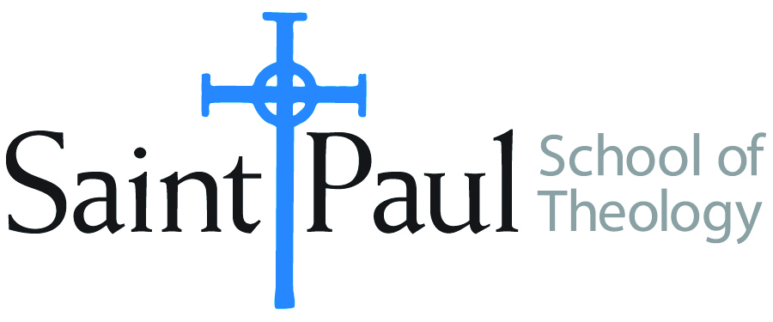
COURSE TEXTBOOK LIST INFORMATION

FACULTY INSTRUCTIONS |  |  | STUDENT INSTRUCTIONS  (Both Campuses)
For each semester taught, faculty should complete and submit a new form for every course Forms are due by the first day of registration for a given term. |  |  | Students may acquire textbooks by ordering online
COURSE INSTRUCTOR(S) | Mike Graves
COURSE NUMBER & SECTION | PCM 331
COURSE NAME | Help for Beginning Preachers
COURSE SEMESTER &YEAR | Spring 2023
DATE OF SUBMISSION | October 12, 2022

REQUIRED TEXTBOOKS LIST
BOOK TITLE and EDITION  (include subtitle if applicable) |  | AUTHOR(S) | No. of  PAGES to be read | PUBLISHER and DATE | 13-Digit ISBN  (without dashes) | LIST PRICE  (estimate) | DESK COPY
1 | The Fully Alive Preacher | Mike Graves | 200 | WJK 2006 | 978-0664230203 | 20
2
3
4
5
6
7
 | TOTAL Number of Pages to Be Read

RECOMMENDED TEXTBOOKS LIST
BOOK TITLE and EDITION  (include subtitle if applicable) |  | AUTHOR(S) | No. of  PAGES to be read | PUBLISHER and DATE | 13-Digit ISBN  (without dashes) | LIST PRICE  (estimate) | DESK COPY
1
2
3
4

