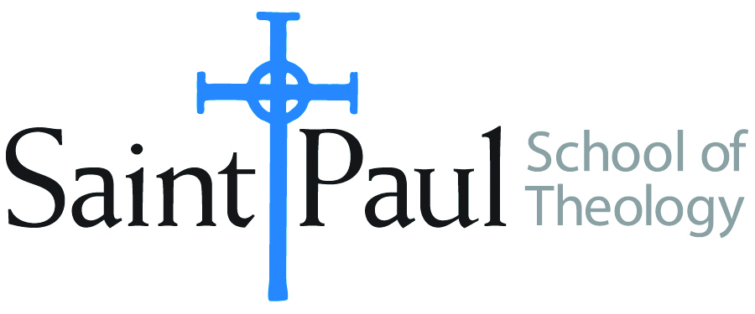
COURSE TEXTBOOK LIST INFORMATION

FACULTY INSTRUCTIONS |  |  | STUDENT INSTRUCTIONS  (Both Campuses)
For each semester taught, faculty should complete and submit a new form each time the course is taught and returned. Forms are due by the first day of registration for a given term.  DESKCOPY – ordered by faculty and adjuncts at a $200 max for 1st time use of text per course. Please fill out an Expense Reimbursement Form, attach all actual/delivered receipts, return via email or mail, and this should be reimbursed with your first stipend payment (or next payroll payment) |  |  | Students may acquire textbooks by ordering online via Amazon or other book retailer and having books shipped to them. Regardless of shopping / ordering method, students may check Cokesbury online for discount on text and certain texts may be sent free delivery.
COURSE INSTRUCTOR(S) | Sharon Betsworth
COURSE NUMBER & SECTION | NTS 430 SO CAM/KS CAM/OK
COURSE NAME | Gospel of John
COURSE SEMESTER & YEAR | Spring 2023
DATE OF SUBMISSION | October 20, 2022

REQUIRED TEXTBOOKS LIST  BOOK TITLE and EDITION  (include subtitle if applicable) |  | AUTHOR(S) | # of PAGES to be read | PUBLISHER and DATE | 13-Digit ISBN  (without dashes) | LIST PRICE  (est)
1 | John 1-10: Wisdom Commentary * | Mary L. Cloe | 281 | 2021 | 9780814681688 | $34.99
2 | John 11-21: Wisdom Commentary * | Mary L. Cloe | 224 | 2021 | 9780814681688 | $36.99
3 | Come and Read: Interpretive Approaches to the Gospel of John | Ed. Alicia D. Meyers & Lindsay S. Jodrey | 246 | 2019 | 9781978707474 | $45 (kindle) / $83 print
4 | The Community of the Beloved Disciples | Raymond Brown, SJ | 208 | 1978 | 9780809121748
5
 | TOTAL Number of Pages to Be Read

* Students will only read of the two volumes; last names A-m John 1-10; Last names n-z John 11-21

RECOMMENDED TEXTBOOKS LIST  BOOK TITLE and EDITION  (include subtitle if applicable) |  |  | AUTHOR(S) | # of PAGES to be read | PUBLISHER and DATE | 13-Digit ISBN  (without dashes) | LIST PRICE  (est)
1
2
3
4

