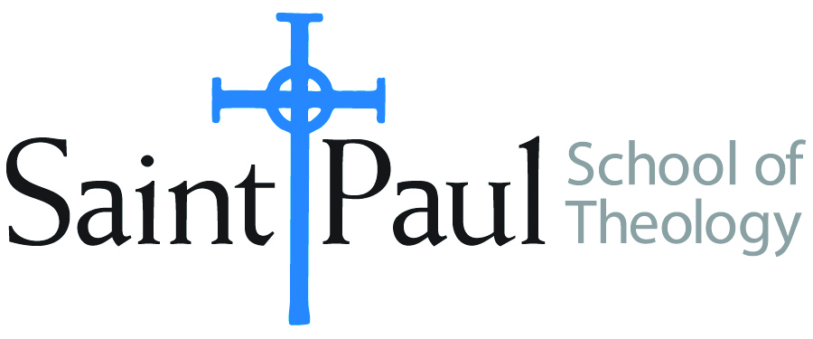
COURSE TEXTBOOK LIST INFORMATION

FACULTY INSTRUCTIONS |  |  | STUDENT INSTRUCTIONS  (Both Campuses)
For each semester taught, faculty should complete and submit a new form each time the course is taught and returned. Forms are due by the first day of registration for a given term.  DESKCOPY – ordered by faculty and adjuncts at a $200 max for 1st time use of text per course. Please fill out an Expense Reimbursement Form, attach all actual/delivered receipts, return via email or mail, and this should be reimbursed with your first stipend payment (or next payroll payment) |  |  | Students may acquire textbooks by ordering online via Amazon or other book retailer and having books shipped to them. Regardless of shopping / ordering method, students may check Cokesbury online for discount on text and certain texts may be sent free delivery.
COURSE INSTRUCTOR(S) | Dr. Kristen E. Kvam
COURSE NUMBER & SECTION | MIN 340 and 341: On Campus and Synchronous Online
COURSE NAME | Women, Society, and Church Studies Seminar
COURSE SEMESTER & YEAR | Spring 2023
DATE OF SUBMISSION | September 30, 2022

REQUIRED TEXTBOOKS LIST  BOOK TITLE and EDITION  (include subtitle if applicable) |  | AUTHOR(S) | # of PAGES to be read | PUBLISHER and DATE | 13-Digit ISBN  (without dashes) | LIST PRICE  (est)
1 | Language for God: A Lutheran Perspective | Streufert, Mary J | 160 | Fortress Press, 2022 | 9781506473963 | $18.52 and up
2 | A Women’s Lectionary for the Whole Church: Year W | Gafney, Wilda C | 24 | Church Publishing, 2021 | 9781640654747 | $23.21 and up or access electronically
3 | Hope Deferred: Heart-Healing Reflections on Reproductive Loss, “Rupture.” ed by Nadine Pence Frantz and Mary T. Stimming, 47-65 | Jones, Serene | 18 | Pilgrim Press, 2005 | 9780829816174 | $13.98 and up (on abebook.com)
4
5
6
7
8
 | TOTAL Number of Pages to Be Read |  | 202

RECOMMENDED TEXTBOOKS LIST  BOOK TITLE and EDITION  (include subtitle if applicable) |  |  | AUTHOR(S) | # of PAGES to be read | PUBLISHER and DATE | 13-Digit ISBN  (without dashes) | LIST PRICE  (est)
1 |  | Feminist Biblical Interpretation: “Galatians: On Discomfort about Gender and Other Problems of Otherness” (Kahl) | Schottroff, Luise and Wacker, Marie-Theres |  | WM. B. Eerdmans, 2012 | 9780802860972 | $41.99 (on christianbooks.com)
2 |  | Children’s Letters to God | Hample, Stuart |  | Workman Publishing Company, 1991 | 9870894809996 | $3.84 and up (on abebooks.com)
3 |  | The Children’s God | Heller, |  | The University of Chicago Press, 1986 | 9780226326368 | $6.59 and up (on thriftbooks.com)
4 |  | Reviving Sacred Speech: The Meaning of Liturgical Language: Second Thoughts on Christ in Sacred Speech | Ramshaw, Gail |  | O S L Pubns, 2000 | 9781878009364 | $5.19 and up (on abebook.com)
5 |  | The Divine Name(s) and the Holy Trinity, Volume One: Distinguishing the Voices | Soulen, R. Kendall |  | Westminster John Knox Press, 2011 | 9780664234140 | $17.70 and up (on abebook.com)
6 |  | Speaking the Christian God: The Holy Trinity and the Challenge of Feminism | Kimel, Alvin |  | Wm. B. Eerdmans-Lightning Source, 1992 | 9780802806123 | $6.69 and up (on abebook.com)
7 |  | Gender and the Name of God: The Trinitarian Baptismal Formula | Duck, Ruth |  | Pilgrim Press, 1991 | 9780829808940 | $6.49 and up (on thriftbooks.com)

NOTE WeLL: REcommended Texts Will be discussed in Class along with Dr. Kvam’s reasons for recommending them in the context of this course.

Kris Kvam suggests the purchase of used books through websites such as ABEBooks.com, christianbook.com, thriftbooks.com, or through Used Bookstores such as Steel’s Used Christian Books in Kansas city

