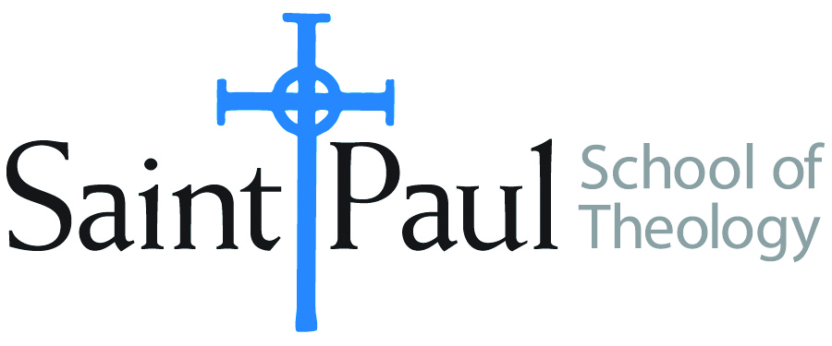
COURSE TEXTBOOK LIST INFORMATION

FACULTY INSTRUCTIONS |  |  | STUDENT INSTRUCTIONS  (Both Campuses)
For each semester taught, faculty should complete and submit a new form each time the course is taught and returned. Forms are due by the first day of registration for a given term.  DESKCOPY – ordered by faculty and adjuncts at a $200 max for 1st time use of text per course. Please fill out an Expense Reimbursement Form, attach all actual/delivered receipts, return via email or mail, and this should be reimbursed with your first stipend payment (or next payroll payment) |  |  | Students may acquire textbooks by ordering online via Amazon or other book retailer and having books shipped to them. Regardless of shopping / ordering method, students may check Cokesbury online for discount on text and certain texts may be sent free delivery.
COURSE INSTRUCTOR(S) | Oden
COURSE NUMBER & SECTION | HST 462
COURSE NAME | Christian Spirituality
COURSE SEMESTER & YEAR | Spring 2023
DATE OF SUBMISSION | October 17, 2022

REQUIRED TEXTBOOKS LIST  BOOK TITLE and EDITION  (include subtitle if applicable) |  | AUTHOR(S) | # of PAGES to be read | PUBLISHER and DATE | 13-Digit ISBN  (without dashes) | LIST PRICE  (est)
1 | Streams of Living Water | Richard Foster | 448 | Harper One 2001 | 978-0060628222 | $10.00
2 | Joy Unspeakable | Barbara Holmes | 264 | Fortress Press 2017 | 978-1506421612 | $20.00
3 | Creating a Life with God: The Call of Ancient Prayer Practices | Daniel Wolpert | 200 | Upper Room, 2003 | 978-0835898553 | $15.00
4 | Right Here Right Now | Amy Oden | 128 | Abingdon Press, 2017 | 978-1501832499 | $15.00
5 | Articles posted on Moodle |  | 300
6
7
 | TOTAL Number of Pages to Be Read |  | 1300

RECOMMENDED TEXTBOOKS LIST  BOOK TITLE and EDITION  (include subtitle if applicable) |  |  | AUTHOR(S) | # of PAGES to be read | PUBLISHER and DATE | 13-Digit ISBN  (without dashes) | LIST PRICE  (est)
1
2
3
4

