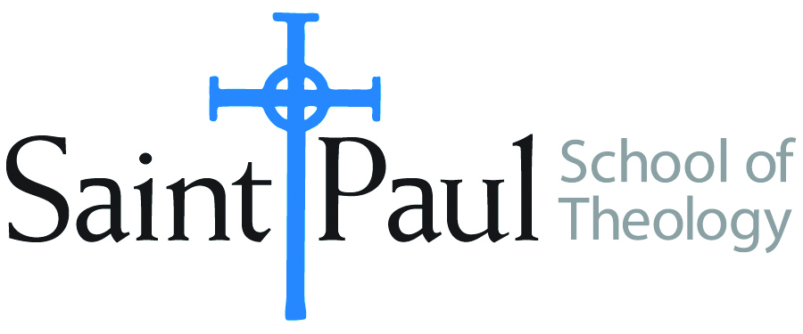
COURSE TEXTBOOK LIST INFORMATION

FACULTY INSTRUCTIONS |  |  | STUDENT INSTRUCTIONS  (Both Campuses)
For each semester taught, faculty should complete and submit a new form for every course and return. Forms are due by the first day of registration for a given term. Desk copies for Teaching Assistants must be requested on this form. It is up to the publishers’ discretion whether or not to provide desk copies for teaching assistants. |  |  | Students may acquire textbooks by ordering online
COURSE INSTRUCTOR(S) | Elaine Robinson
COURSE NUMBER & SECTION | DST 330 ON
COURSE NAME | United Methodist Polity
COURSE SEMESTER &YEAR | Spring 2023
DATE OF SUBMISSION | October 12, 2022

REQUIRED TEXTBOOKS LIST
BOOK TITLE and EDITION  (include subtitle if applicable) |  | AUTHOR(S) | No. of  PAGES to be read | PUBLISHER and DATE | 13-Digit ISBN  (without dashes) | LIST PRICE  (estimate) | DESK COPY
1 | 2016 Book of Discipline of the United Methodist Church |  | Skim for Famil-iarity | United Methodist Publishing House, 2016 | 9781501833236 | $24
2 | Polity, Practice, and the Mission of The United Methodist Church | Frank, Thomas | 150 | Abingdon, 2006 | 9780687335312 | $20
3
4
5
6
7
 | TOTAL Number of Pages to Be Read |  | 150+

RECOMMENDED TEXTBOOKS LIST
BOOK TITLE and EDITION  (include subtitle if applicable) |  | AUTHOR(S) | No. of  PAGES to be read | PUBLISHER and DATE | 13-Digit ISBN  (without dashes) | LIST PRICE  (estimate) | DESK COPY
1
2
3
4

:

