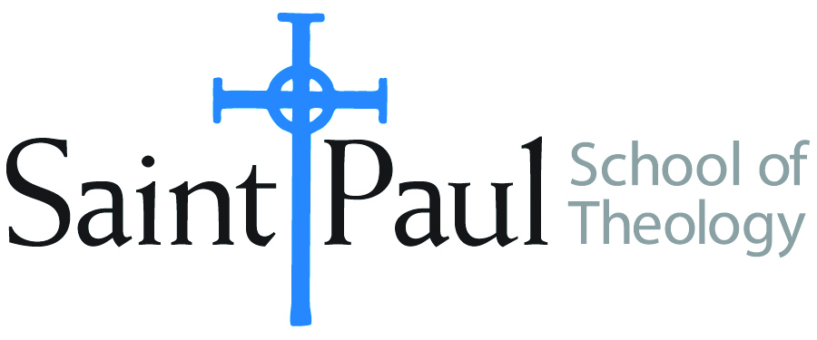
COURSE TEXTBOOK LIST INFORMATION

FACULTY INSTRUCTIONS |  |  | STUDENT INSTRUCTIONS  (Both Campuses)
Forms are due by the first day of registration for a given term. Desk copies for Teaching Assistants must be requested on this form. It is up to the publishers’ discretion whether or not to provide desk copies for teaching assistants. |  |  | Students may acquire textbooks by ordering online or directly from the publisher, which in some cases, the prices are more economical. Regardless of shopping/ordering method, students may check Cokesbury online for discount on text, or follow recommendations by your professor.
COURSE INSTRUCTOR(S) | Robinson
COURSE NUMBER & SECTION | CHL 391 CAM/KS CAM/OK SO
COURSE NAME | Adaptive Church Leadership
COURSE SEMESTER &YEAR | Spring 2023
DATE OF SUBMISSION | October 12, 2022

REQUIRED TEXTBOOKS LIST
BOOK TITLE and EDITION  (include subtitle if applicable) |  | AUTHOR(S) | No. of  PAGES to be read | PUBLISHER and DATE | 13-Digit ISBN  (without dashes) | LIST PRICE  (estimate) | DESK COPY
1 | The Practice of Adaptive Leadership | Heifetz, Grashow, Linsky | 300 | Harvard Business Press, 2009 | 9781422105764 | $21
2 | Canoeing the Mountains: Christian Leadership in Uncharted Territory | Bolsinger, Tod | 200 | IVP Books, 2015 | 9780830841479 | $20
3 | The New Parish: How Neighborhood Churches are Transforming Mission, Discipleship, and Community | Sparks, Soerens, Friesen | 150 | IVP Books,2014 | 9780830841158 | $14
4
5
6
7
 | TOTAL Number of Pages to Be Read |  | 650

RECOMMENDED TEXTBOOKS LIST
BOOK TITLE and EDITION  (include subtitle if applicable) |  | AUTHOR(S) | No. of  PAGES to be read | PUBLISHER and DATE | 13-Digit ISBN  (without dashes) | LIST PRICE  (estimate) | DESK COPY
1
2
3
4

Special Instructions to Cokesbury:

