Saint Paul School of Theology
Course of Study 421
Bible IV: Prophets, Psalms, and Wisdom Literature
Summer Session - 2022

Instructor: Choongho Kwon
Email: ckwon0322@gmail.com
Phone: 816-398-2779

Course Description
This course introduces students to critical theological study of the Latter Prophets (Isaiah, Jeremiah, Ezekiel, and the Twelve), Psalms and Wisdom Literature (Proverbs, Job, and Ecclesiastes). Students will appreciate the historical contexts and literary artistry of selected passages from the Biblical books and explore the significance of interpretive issues for the life of the Church.

Course Objectives
Students will be able to:
- Understand the historical and cultural setting and theological emphases of these forms of biblical literature among God’s people.
- Exegete selected passages from these forms of biblical literature.
- Apply exegesis to preaching, other pastoral responsibilities, and issues of the present day.

TEXTBOOKS for COS 421
Required Textbooks
An Introduction To The Old Testament: The Canon and Christian Imagination (Third Edition), Walter Brueggemann and Tod Linafelt, Westminster John Knox Press, 2020, ISBN-13 :‎ 978-0664264413

You Are My People: An Introduction to Prophetic Literature, Louis Stulman and Hyun Chul Paul Kim, Abingdon Press, 2010, ISBN-13 :‎ 978-0687465651

Recommended Texts

A Theological Introduction to the Old Testament (Second Edition), Bruce Birch, Walter Brueggemann, Terence Frethem, and David Petersen, Abingdon Press, 2005, ISBN-13‏ :‎ 978-0687066766

Spirituality of the Psalms. Walter Brueggemann, Fortress Press, 2002, ISBN-13‏ : ‎978-0800634506

The Wisdom Literature, Richard Clifford, Abingdon Press, 1998, ISBN-13 :‎ 978-0687008469

Wondrous Depth: Preaching the Old Testament, Ellen Davis, Westminster John Knox Press, 2005, ISBN-13 : 978-0664228590

The New Oxford Annotated Bible with Apocrypha: New Revised Standard Version (Fifth Edition), Michael Coogan (Editor), Oxford University Press, 2018, ISBN-13 : 978-0190276089

ASSIGNMENTS:
Advance Assignment 1 (5-page essay)
Describe your personal history with the Bible as unfolding in several important life stages (such as what the Bible meant when you read it for the first time, how you picked the Scripture passage for your first sermon, what you have learned from critical biblical study of COS, your current process of sermon preparation, etc.) and what you expect to learn from this course.
(Due Date: Assignment #1 is to be uploaded to Moodle on or before August 1, 2022)

Assignment 2 (10-page textbook analysis)
Compare and contrast the historical setting and theological emphases of Isaiah, Jeremiah and Ezekiel based on the textbooks: You Are My People and An Introduction To The Old Testament.
(Due Date: Assignment #2 is to be uploaded to Moodle on or before August 1, 2022.)

Assignment 3 (5-page exegesis paper)
Write an exegesis (3 page) and sermon outline (2 page) following the methodology provided in class on July 25
(Due Date: Assignment #3 is to be uploaded to Moodle on or before August 15, 2022.)

Moodle (online) Forums
Week of July 11-15
- Topic: the interpretive issues of Isaiah 7:14
- Due Date: initial posts by July 13 and responses by July 15
- Recommended text: Brueggemann, Am Introduction to the Old Testament, 173-175

- Topic: the interpretive issue of Jeremiah 31:31-34
- Due Date: initial posts by July 13 and responses by July 15
- Recommended text: Brueggemann, Am Introduction to the Old Testament, 189-190

Week of July 18-23
- Topic: the literary artistry of Psalms and the Book of Job
- Due Date: initial posts by July 20 and responses by July 22
- Recommended text: Brueggemann, Am Introduction to the Old Testament, 277–303

- Topic: the functions of “interpretation, imagination, inspiration, and ideology (theology)” in sermon preparation
- Due Date: initial posts by July 20 and responses by July 22
- Recommended text: Brueggemann, Am Introduction to the Old Testament, 401–402

- Students engage these forums by making initial posts (250 – 300) in response to the forum topics. You may wish to reference course texts, narrated PowerPoints, videos, or other material.
- Students will then respond to initial posts by two other students in each of the two forums each week (50 – 100 words)
- Initial forum posts by students must be done by Wednesday by 11:59 pm of each week to allow students to write at least two responses to their classmates by Friday 11:59 pm.
- Forum postings on time will count and be graded as class participation and attendance.

ZOOM ONLINE CLASS DAY MEETING
Orientation Date: July 11 (6:00 pm - 8:00 pm CST)
Class Date: July 25 (8:00 am - 12:00 pm and 1:00 pm - 5:00 pm CST)
Classes will be held via Zoom for 10 hours (combination of orientation and class day) to meet GBHEM policies and educational best practices.

You will receive a zoom invite with link from (instructor). A computer or tablet with a camera are preferred – and please plan to have your camera on during class to facilitate discussion.

Final LETTER Grades
Special notes:
- Late papers receive a grade no higher than C (unless by special accommodation) and may receive no credit.
- Missing one class session or 20% of a class work results in no credit for the course. [See the COS policy below]
- Please outline the percentages/weight of each module, ie. Forums, each assignment, etc. This is currently shown on the Moodle class page, but you may change this.
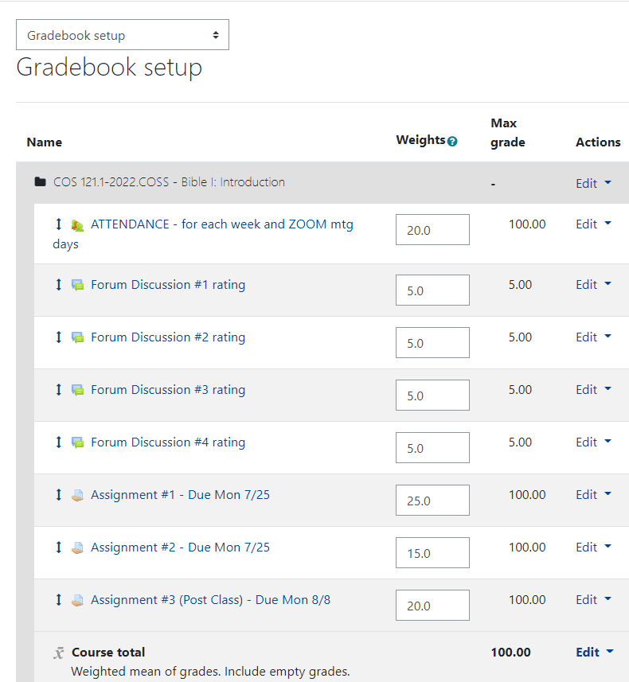

- Students will want assignments graded with feedback in a timely manner.

Course Policies:
In this course, we have multiple accountabilities. First, we are accountable to the Triune God and the Christian life and work to which we are called. Second, we are accountable to the Church and to the believers who make up the COS community. Third, we (instructor and students) are accountable to the Course of Study Policies and Guidelines, which help us to be faithful to our calls, the Church, and each other. I refer you to the GBHEM COS Policies but will highlight a few important expectations in this course.

Class Attendance
“A student is expected to attend every class session. Unexcused absences may be cause for loss of credit or dismissal from the school. A student missing twenty percent (20%) or more of the classroom (and/or zoom) work shall not receive credit for those classes. Online work shall be included in the attendance policy.” [GBHEM COS Policies and Guidelines, page 5]

Academic Integrity Statement/Plagiarism
All students are expected to document the sources they use in their written work properly. All words from the source should be quoted and cited even if only one unique word, a phrase, or model and typology headings. The use of a concept, idea, or fact must also be given recognition.

Any violation of COS’s policy on may result in a zero for the assignment, course, and disciplinary action against the student may be taken, including, but not limited to, dismissal.

Note from the instructor: To avoid plagiarism, which is taking someone else’s ideas or words/phrases/sentences and representing them as your own. In this course, be sure to use quotation marks to indicate when you’re quoting an author. Use footnotes to cite the places where anyone can find the quoted material or ideas. I recommend using Kate L. Turabian’s A Manual for Writers. See the folder posted in Moodle to learn the style expected. A quick reference guide is found at: https://www.chicagomanualofstyle.org/turabian/turabian-notes-and-bibliography-citation-quick-guide.html
See/contact the instructor whenever you need writing support or advice.

Sexual Harassment and Racial Harassment
Note from the instructor: The two policies are too lengthy to quote here, but I refer you to the texts in the GBHEM COS Policies and Guidelines, pages 19-23. Needless to say, the expected practice in our classroom will be to encourage, respect, and support each other in our work. The classroom is not a competitive or contentious place, but a collaborative and mutually responsible setting.

Learning Accommodation
As part of its commitment to equal opportunity, the Seminary is committed to providing qualified individuals with disabilities with reasonable accommodation. Students seeking accommodation should contact Margaretta Narcisse, the Associate Dean of Student Affairs, at margaretta.narcisse@spst.edu.

This office maintains the forms necessary for medical documentation of disabilities required before any accommodation can be considered. Following receipt of medical documentation from the student, the Associate Dean of Student Affairs will determine reasonable accommodations for specified needs, including identifying persons to whom this information will be released.

GBHEM POLICY:
https://www.spst.edu/wp-content/uploads/2021/09/COS-Policies-and-Guidelines-v.2021.pdf

