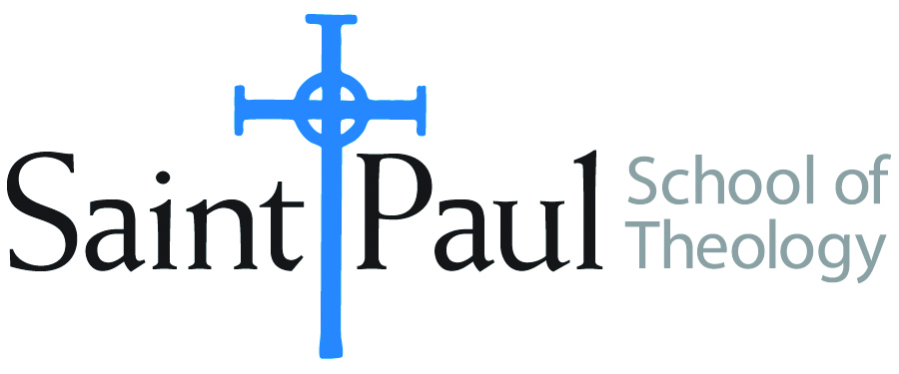
COURSE TEXTBOOK LIST INFORMATION

FACULTY INSTRUCTIONS |  |  | STUDENT INSTRUCTIONS  (Both Campuses)
For each semester taught, faculty should complete and submit a new form each time the course is taught and returned. Forms are due by the first day of registration for a given term.  DESKCOPY – ordered by faculty and adjuncts at a $200 max for 1st time use of text per course. Please fill out an Expense Reimbursement Form, attach all actual/delivered receipts, return via email or mail, and this should be reimbursed with your first stipend payment (or next payroll payment) |  |  | Students may acquire textbooks by ordering online via Amazon or other book retailer and having books shipped to them. Regardless of shopping / ordering method, students may check Cokesbury online for discount on text and certain texts may be sent free delivery.
COURSE INSTRUCTOR(S) | Kris Kvam
COURSE NUMBER & SECTION | THL 425 On Line
COURSE NAME | Christ and Salvation
COURSE SEMESTER & YEAR | Fall Semester, 2022
DATE OF SUBMISSION | March 3, 2022

REQUIRED TEXTBOOKS LIST  BOOK TITLE and EDITION  (include subtitle if applicable) |  | AUTHOR(S) | # of PAGES to be read | PUBLISHER and DATE | 13-Digit ISBN  (without dashes) | LIST PRICE  (est)
1 | Cur Deus Homo (Why the God Human) [often bundled with Proslogium and other texts as in Deane’s Saint Anselm: Basic Writings or Fairweather’s A Scholastic Miscellany | Anselm of Canterbury | 116 |  |  | $ 6.00 used
2 | The Cross and the Lynching Tree | Cone, James H. | 204 | Orbis: 2013 | 9781626980051 | $11.00 used
3 | Knowing Christ Crucified: The Witness of African American Religious Experience | Copeland, M. Shawn | 176 | Orbis: 2018 | 9781626982987 | $12.00 used
4 | Jesus Wept: The Significance of Jesus’ Laments in the New Testament | Eklund, Rebekah | 172 | Bloomsbury: 2015 | 9780567671820 | $34.00 from Bloomsbury; 45.00 used.
5 | Consider Jesus: New Waves of Renewal in Christoloty | Johnson, Elizabeth A. | 150 | Crossroads: 1990 | 9780824511616 | $ 4.00, used
6 | Imagining Redemption | Kelsey, David H. | 106 | Westminster: 2005 | 9780664228897 | $ 6.00 used
7 | Jesus the Savior: The Meaning of Jesus Christ for Christian Faith | Placher, William C. | 221 | Westminster: 2001 | 9780664223915 | $ 4.00 used
 | TOTAL Number of Pages to Be Read

RECOMMENDED TEXTBOOKS LIST  BOOK TITLE and EDITION  (include subtitle if applicable) |  |  | AUTHOR(S) | # of PAGES to be read | PUBLISHER and DATE | 13-Digit ISBN  (without dashes) | LIST PRICE  (est)
1
2

