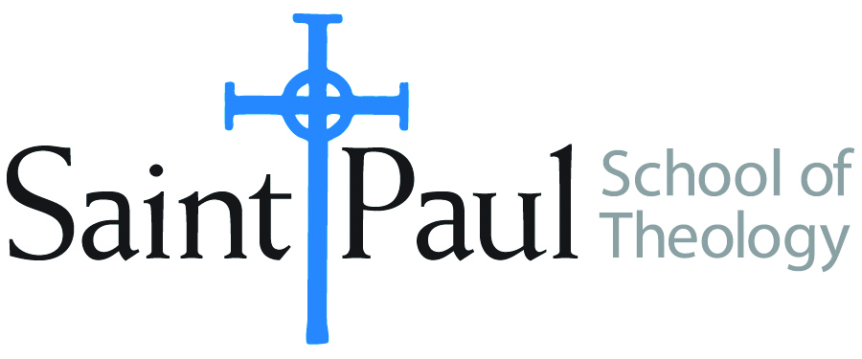
COURSE TEXTBOOK LIST INFORMATION

FACULTY INSTRUCTIONS |  |  | STUDENT INSTRUCTIONS  (Both Campuses)
For each semester taught, faculty should complete and submit a new form each time the course is taught and returned. Forms are due by the first day of registration for a given term.  DESKCOPY – ordered by faculty and adjuncts at a $200 max for 1st time use of text per course. Please fill out an Expense Reimbursement Form, attach all actual/delivered receipts, return via email or mail, and this should be reimbursed with your first stipend payment (or next payroll payment) |  |  | Students may acquire textbooks by ordering online via Amazon or other book retailer and having books shipped to them. Regardless of shopping / ordering method, students may check Cokesbury online for discount on text and certain texts may be sent free delivery.
COURSE INSTRUCTOR(S) | Christina McLewin
COURSE NUMBER & SECTION | PCM 326 CAM/KS/FW
COURSE NAME | Suicide: Prevention, Intervention and Grief
COURSE SEMESTER & YEAR | Fall 2022 – 10/11/22, 8-5:00
DATE OF SUBMISSION | March 23, 2022

REQUIRED TEXTBOOKS LIST  BOOK TITLE and EDITION  (include subtitle if applicable) |  | AUTHOR(S) | # of PAGES to be read | PUBLISHER and DATE | 13-Digit ISBN  (without dashes) | LIST PRICE  (est)
1 | Suicide: Pastoral Responses | Loren Townsend | 144 | Abingdon Press, 2006 | 9780687492978 | $19.55
2
3
4
5
 | TOTAL Number of Pages to Be Read |  | 144

RECOMMENDED TEXTBOOKS LIST  BOOK TITLE and EDITION  (include subtitle if applicable) |  |  | AUTHOR(S) | # of PAGES to be read | PUBLISHER and DATE | 13-Digit ISBN  (without dashes) | LIST PRICE  (est)
1 |  | Stay: A History of Suicide and the Arguments Against It | Jennifer Michael Hecht | 288 | Yale University Press, 2015 | 9780300209365 | $15.99
2 |  | The Grief Recovery Handbook | John W. James & Russell Friedman | 240 | William Morrow Paperbacks, 2017 | 9780061686078 | $10.99
3
4

