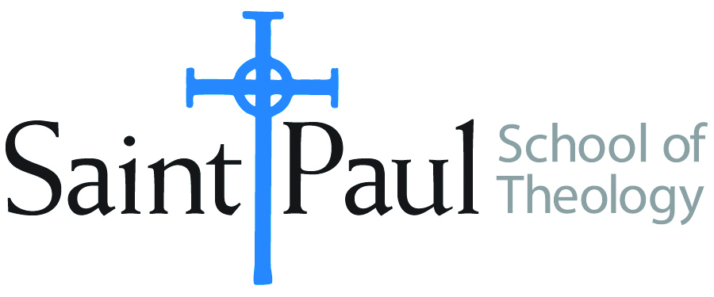
COURSE TEXTBOOK LIST INFORMATION

FACULTY INSTRUCTIONS |  |  | STUDENT INSTRUCTIONS  (Both Campuses)
For each semester taught, faculty should complete and submit a new form for every course and return to Melissa Whalen in the Academic Life office. Forms are due by the first day of registration for a given term. Desk copies for Teaching Assistants must be requested on this form. It is up to the publishers’ discretion whether or not to provide desk copies for teaching assistants. |  |  | Students may acquire textbooks by ordering online via Amazon and having books shipped to them. Regardless of shopping/ordering method, students may check Cokesbury online for discount on text and certain text may be sent free delivery.
COURSE INSTRUCTOR(S) | Dr. Kristen Kvam
COURSE NUMBER & SECTION | EWR 313
COURSE NAME | Engaging World Religions: People of the Book
COURSE SEMESTER &YEAR | Fall 2022
DATE OF SUBMISSION | March 2, 2022
REQUIRED TEXTBOOKS LIST
BOOK TITLE and EDITION  (include subtitle if applicable) |  | AUTHOR(S) | No. of  PAGES to be read | PUBLISHER and DATE | 13-Digit ISBN  (without dashes) | LIST PRICE  (estimate)
1 | Living Traditions of the Bible: Scripture in Jewish, Christian, and Muslim Practice | James Bowley, ed. | 207 | Chalice Press, 1999 | 9780827221277 | 6.00
2 | The Qur’an | M.A.S. Abdel Haleen, ed. | 100 pages | Oxford World Classics, 2008 | 9780199535958 | 7.50
3 | “The Issue of Woman-Man Equality in the Islamic Tradition” in Eve and Adam: Jewish, Christian, and Muslim Readings on Genesis and Gender, pages 463-476 . | Kvam, Schearing, and Ziegler, eds. | 13 pages | Indiana University Press, 1999 | 9780253212719 | 8.00
4 | Heirs of Abraham: The Future of Muslim, Jewish, and Christian Relations | Hinze and Omar, eds. | 150 | Wipf and Stock, 2013 | 9781620327609 | 14.00
5 | The Faith Club: A Muslim, a Christian, A Jew – Three Women Search for Understanding | Idliby, Oliver, and Warner | 325 | Atria Books, 2007 | 9780743290487 | 8.00
6 | “Interfaith Relations and the Churches: A Policy Statement of the National Council of Churches” (1999) | National Council of Churches of Christ in the USA | 12 | http://nationalcouncilofchurches.us | download
7 | “Getting to Know Neighbors of Other Faiths: A Theological Rationale for Interfaith Relationships” (resource brochure) | National Council of Churches of Christ in the USA | 4 pages | http://nationalcouncilofchurches.us | download
8 | The Book of Resolutions of The United Methodist Church, 2016. | The United Methodist Church | 15—20 pages
9 | “A Wesleyan Theology of Religions” in Methodist Review 10 (2018) | Wingeier-Rayo, Philip | 23 pages | ISSN: 1946-5254 (online)  URL: www.methodistreview.org | download
10 | Hagar, Sarah, and Their Children: Jewish, Christian, and Muslim Perspectives | Trible and Russell, eds. | 200 | Westminster John Knox, 2006 | 9780664228825 | 8.00
 | TOTAL Number of Pages to Be Read |  | 1054 pages

RECOMMENDED TEXTBOOKS LIST
BOOK TITLE and EDITION  (include subtitle if applicable) |  | AUTHOR(S) | No. of  PAGES to be read | PUBLISHER and DATE | 13-Digit ISBN  (without dashes) | LIST PRICE  (estimate)
1 | Your God, My God, Our God: Rethinking Christian Theology for Religious Plurality | Ariarajah, S. Wesley |  | WCC Publications: 2012
2 | Shared Stories, Rival Tellings: Early Encounters of Jews, Christians, and Muslims | Gregg, Robert C |  | Oxford University Press, 2015
3 | Feminist Edges of the Qur’an | Hidayatullah, Aysha |  | Oxford, 2014 | 9780199359578
4 | The Bible Tells Me So: Uses and Abuses of Holy Scripture | Hill, Jim, and Rand Cheadle |  | Anchor Books, 1996
5 | Families of Faith: An Introduction to World Religions for Christians | Martinson, Paul V. |  | Fortress, 1999 | 9780800632229
6 | Interfaith Relations and Christian Living: Study and Action Suggestions | National Council of Churches of Christ in the USA |  | www.nationalcouncilofchurches
7 | Interreligious Relations and the Church: Key Study Guides (missional, moral, theological, ecumenical, identity) | National Council of Churches of Christ in the USA |  | www.nationalcouncilofchurches
8 | Three Faiths, One God: The Formative Faith and Practice of Judaism, Christianity, and Islam | Neusner, Jacob, and Bruce Chilton |  | Brill, 2003
9 | Faith and Feminism: Ecumenical Essays | Trible and Lipsett, eds. |  | Westminster John Knox, Nov. 2014 | 9780664239695
10 | Christian Witness in a Multi-Religious World: Recommendations for Conduct | World Council of Churches, et al. |  | www.oikoumene.org
11 | Honoring Our Neighbor’s Faith |  |  | Augsburg Fortress | 9780806638461
12 | Christianity and Plurality: Classic and Contemporary Readings | Plantinga, Richard |  | Blackwell, 1999 | 9780631209157 | 83
13. A MANUAL FOR WRITERS—a RECENT EDITION TURABIAN, KATE, et Al. University of Chicago

Special Instructions:
Texts are Recommended for a variety of reasons. This reasons WILL BE DESCRIBED DURING CLASS SESSIONS. KEK

