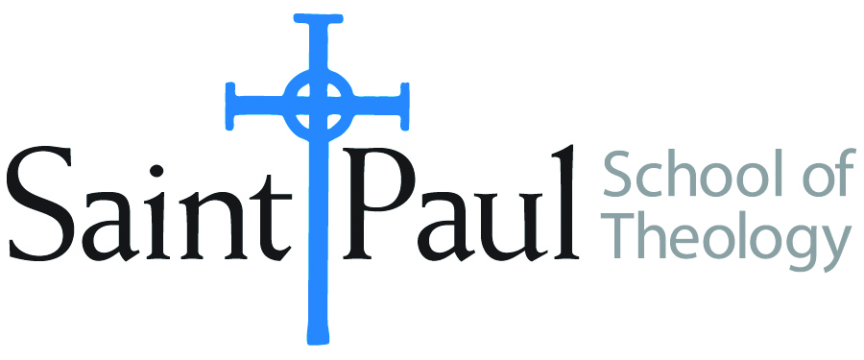
COURSE TEXTBOOK LIST INFORMATION

FACULTY INSTRUCTIONS |  |  | STUDENT INSTRUCTIONS  (Both Campuses)
For each semester taught, faculty should complete and submit a new form each time the course is taught and returned. Forms are due by the first day of registration for a given term.  DESKCOPY – ordered by faculty and adjuncts at a $200 max for 1st time use of text per course. Please fill out an Expense Reimbursement Form, attach all actual/delivered receipts, return via email or mail, and this should be reimbursed with your first stipend payment (or next payroll payment) |  |  | Students may acquire textbooks by ordering online via Amazon or other book retailer and having books shipped to them. Regardless of shopping / ordering method, students may check Cokesbury online for discount on text and certain texts may be sent free delivery.
COURSE INSTRUCTOR(S) | Joshua S. Bartholomew
COURSE NUMBER & SECTION | ETH 301 – CAM KS/OK, ON, OS
COURSE NAME | Introduction to Christian Ethics
COURSE SEMESTER & YEAR | Fall 2022
DATE OF SUBMISSION | 3/15/2022

REQUIRED TEXTBOOKS LIST  BOOK TITLE and EDITION  (include subtitle if applicable) |  | AUTHOR(S) | # of PAGES to be read | PUBLISHER and DATE | 13-Digit ISBN  (without dashes) | LIST PRICE  (est)
1 | Social Ethics in the Making: Interpreting an American Tradition | Gary Dorrien | 200 | Wiley-Blackwell, 2010 | 9781405186872 | $50
2 | Womanist Theological Ethics: A Reader | Katie Cannon, et al | 235 | Westminster John Knox, 2011 | 9780664235376 | $24
3 | Doing Ethics from the Margins | Miguel Del La Torre, et al | 170 | Orbis Books, 2014 | 9781626980754 | $28
4
 | TOTAL Number of Pages to Be Read

RECOMMENDED TEXTBOOKS LIST  BOOK TITLE and EDITION  (include subtitle if applicable) |  |  | AUTHOR(S) | # of PAGES to be read | PUBLISHER and DATE | 13-Digit ISBN  (without dashes) | LIST PRICE  (est)
1 |  | Faith and Reckoning After Trump | Miguel De La Torre, et al |  | Orbis Books, 2021 | 9781626984423 | $26
2

