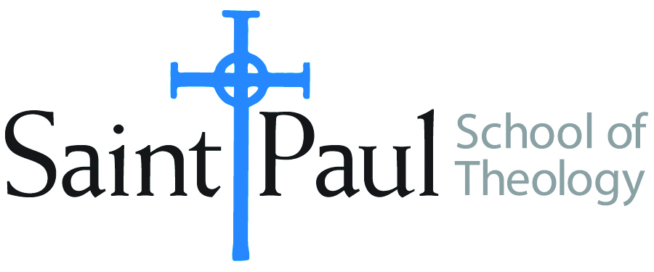
COURSE TEXTBOOK LIST INFORMATION

FACULTY INSTRUCTIONS |  |  | STUDENT INSTRUCTIONS  (Both Campuses)
For each semester taught, faculty should complete and submit a new form each time the course is taught and returned. Forms are due by the first day of registration for a given term.  DESKCOPY – ordered by faculty and adjuncts at a $200 max for 1st time use of text per course. Please fill out an Expense Reimbursement Form, attach all actual/delivered receipts, return via email or mail, and this should be reimbursed with your first stipend payment (or next payroll payment) |  |  | Students may acquire textbooks by ordering online via Amazon or other book retailer and having books shipped to them. Regardless of shopping / ordering method, students may check Cokesbury online for discount on text and certain texts may be sent free delivery.
COURSE INSTRUCTOR(S) | Kris Kvam
COURSE NUMBER & SECTION | ASR 401: all sections; all modes: camp KS; camp OK; hybrid
COURSE NAME | Mid-Degree Seminar
COURSE SEMESTER & YEAR | Fall, 2022
DATE OF SUBMISSION | March 3, 2022

REQUIRED TEXTBOOKS LIST  BOOK TITLE and EDITION  (include subtitle if applicable) |  | AUTHOR(S) | # of PAGES to be read | PUBLISHER and DATE | 13-Digit ISBN  (without dashes) | LIST PRICE  (est)
1 | Eve and Adam: Jewish, Christian, and Muslim Readings on Genesis and Gender | Kvam, Kristen E.,  Linda S. Schearing, and Valarie H.  Ziegler. | 125or so | Indiana University Press: 1999. | 9780253334909 | From $5.60 used to $40.00 new hardback.
2 | Enticed by Eden: How Western Culture Uses, Confuses, (and Sometimes Abuses) Adam and Eve | Schearing, Linda S., and Valarie H. Ziegler. | 95 pp. | Baylor University Press, 2013 | 9781602585430
3 | Bible, any translation |  | 5-pp.
 | TOTAL Number of Pages to Be Read |  | 225 pp.

RECOMMENDED TEXTBOOKS LIST  BOOK TITLE and EDITION  (include subtitle if applicable) |  |  | AUTHOR(S) | # of PAGES to be read | PUBLISHER and DATE | 13-Digit ISBN  (without dashes) | LIST PRICE  (est)
1 |  | Nashville Statement on Biblical Sexuality | Council on Biblical Manhood and Womanhood |  | July, 2017 | Accessed March 3, 2022. Download from cbmw.org
2 |  | GLAAD Media Reference Guide, 11th edition. |  |  | GLAAD. | Accessed March 3, 2022. https://www.glaad.org/reference.
3 |  | Dictionary of Feminist Theologies | Russell, Letty M. and J. Shannon Clarkson, ed. |  | Wesminster John Knox, 1996.
4 |  | God and the Rhetoric of Sexuality. Overtures to Biblical Theology series. | Trible, Phyllis |  | Fortress Press, 1986.
5 |  | Confessing Our Faith Together: A Study and Discussion Guide. | United Methodist Church and the Evangelical Lutheran Church in America. |  |  | Accessed March 3, 2022. Download from elca.org or umc.org.
6 |  | Christian Perspectives on Theological Anthropology | Commission on Faith and Order of the WCC |  | January 2005 | Accessed March 3, 2022. Download from oikumene.org

