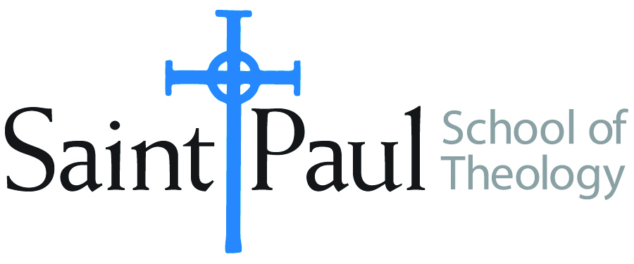
COURSE TEXTBOOK LIST INFORMATION

FACULTY INSTRUCTIONS |  |  | STUDENT INSTRUCTIONS  (Both Campuses)
For each semester taught, faculty should complete and submit a new form each time the course is taught and returned. Forms are due by the first day of registration for a given term.  DESKCOPY – ordered by faculty and adjuncts at a $200 max for 1st time use of text per course. Please fill out an Expense Reimbursement Form, attach all actual/delivered receipts, return via email or mail, and this should be reimbursed with your first stipend payment (or next payroll payment) |  |  | Students may acquire textbooks by ordering online via Amazon or other book retailer and having books shipped to them. Regardless of shopping / ordering method, students may check Cokesbury online for discount on text and certain texts may be sent free delivery.
COURSE INSTRUCTOR(S) | Hal Knight
COURSE NUMBER & SECTION | THL 412
COURSE NAME | Theology and the Church’s Ministry
COURSE SEMESTER & YEAR | Summer 2022
DATE OF SUBMISSION | 12-16-22

REQUIRED TEXTBOOKS LIST  BOOK TITLE and EDITION  (include subtitle if applicable) |  | AUTHOR(S) | # of PAGES to be read | PUBLISHER and DATE | 13-Digit ISBN  (without dashes) | LIST PRICE  (est)
1 | Faith Speaking Understanding | Kevin J. Vanhoozer | 237 | Westminster John Knox, 2014 | 9790664234485
2 | Leadership, God’s Agency, & Disruptions | Mark Lou Branson & Alan J. Roxburgh | 216 | Cascade, 2020 | 9781752571746
3 | Whole & Reconciled | Al Tizon | 215 | Baker, 2018 | 9780801095627
4
5
6
7
8
 | TOTAL Number of Pages to Be Read |  | 668

RECOMMENDED TEXTBOOKS LIST  BOOK TITLE and EDITION  (include subtitle if applicable) |  |  | AUTHOR(S) | # of PAGES to be read | PUBLISHER and DATE | 13-Digit ISBN  (without dashes) | LIST PRICE  (est)
1
2
3
4
5
6

