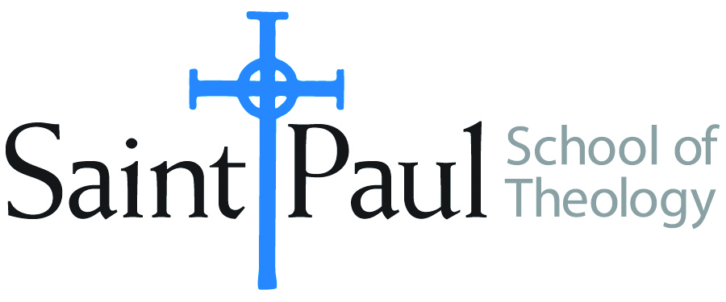
COURSE TEXTBOOK LIST INFORMATION

FACULTY INSTRUCTIONS |  |  | STUDENT INSTRUCTIONS  (Both Campuses)
For each semester taught, faculty should complete and submit a new form each time the course is taught and returned. Forms are due by the first day of registration for a given term.  DESKCOPY – ordered by faculty and adjuncts at a $200 max for 1st time use of text per course. Please fill out an Expense Reimbursement Form, attach all actual/delivered receipts, return via email or mail, and this should be reimbursed with your first stipend payment (or next payroll payment) |  |  | Students may acquire textbooks by ordering online via Amazon or other book retailer and having books shipped to them. Regardless of shopping / ordering method, students may check Cokesbury online for discount on text and certain texts may be sent free delivery.
COURSE INSTRUCTOR(S) | Eyyup Esen, PhD
COURSE NUMBER & SECTION | SFR 301.CAM/KS -
COURSE NAME | Spiritual Growth through Dialogue
COURSE SEMESTER & YEAR | Spring 2022
DATE OF SUBMISSION | 1/20/2022

REQUIRED TEXTBOOKS LIST  BOOK TITLE and EDITION  (include subtitle if applicable) |  | AUTHOR(S) | # of PAGES to be read | PUBLISHER and DATE | 13-Digit ISBN  (without dashes) | LIST PRICE  (est)
1 | Global Warming of Hearts available on Amazon – read prior to retreat | by Shaq Tom (aka Eyyup Esen) | 260 | Independently published (November 16, 2018) | 978-1731364982 | $16
2
 | TOTAL Number of Pages to Be Read

SFR 301.CAM/KS-2022.SPRING - Spiritual Formation Retreat

The retreat will meet on the Leawood campus in Wesley Chapel on Monday March 7, 8:30 - 4:30. Lunch will be served. Students must be present for the day and may not join via Zoom.
Spiritual Growth through Dialogue
This retreat will provide students with a broad understanding of Islamic spiritual practices, including an overview of five-time daily prayers, recitation of attributes of Allah (God) aka tasbihat, and the best practices of Christian- Muslim dialogue. It will also explore Hizmet aka Gulen Movement, Dialogue Institute of Kansas City, and the local dialogue experiences among Muslims and Christians. The retreat will include demonstrations of Islamic art including calligraphy, water marbling, poetry and spiritual songs. The Farewell Speech of Prophet Muhammad (peace be upon him) will be presented in relationship to current issues including racism and women’s rights. The Qu’ran Chapter Mary, the mother of Jesus (pbuh) will also be examined. This will be a time of prayer, poetry, art, quiet reflection, storytelling, and dialogue.

Retreat Leader: Dr. Eyyup Esen
Eyyup Esen, PhD was born and grew up in Turkey. He received his BA in Foreign Languages Teaching from Black Sea Technical University in Turkey, MA in educational studies from University of Cincinnati and a second MA in Communication and Leadership from Park University. He received his PhD in higher education from KU with high honors and currently works as a college access advisor at Wichita State University. He holds a peace education certificate, as well, and is involved in the work of the Dialogue Institute, or what he calls the Movement of Global Warming of Hearts.
Dr. Esen is interested in establishing dialogue with anyone of different cultures and ethnicities and organizes a variety of events to promote peace and dialogue. His goal is to contribute to the global warming of hearts to depolarize the world. He recently published his first book is “Global Warming of Hearts!" He published his second book: “I am not color blind” in November 2020!

