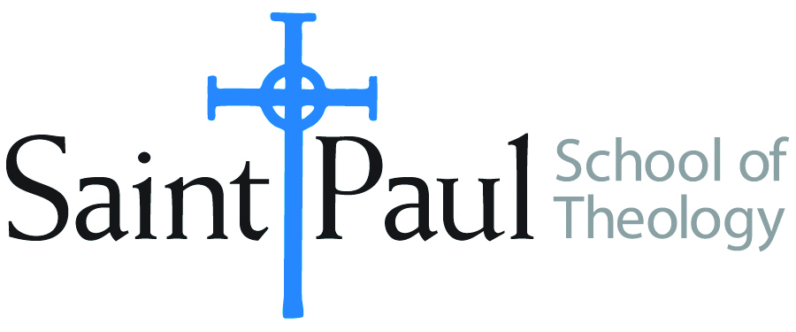
COURSE TEXTBOOK LIST INFORMATION

FACULTY INSTRUCTIONS |  |  | STUDENT INSTRUCTIONS  (Both Campuses)
For each semester taught, faculty should complete and submit a new form each time the course is taught and returned. Forms are due by the first day of registration for a given term.  DESKCOPY – ordered by faculty and adjuncts at a $200 max for 1st time use of text per course. Please fill out an Expense Reimbursement Form, attach all actual/delivered receipts, return via email or mail, and this should be reimbursed with your first stipend payment (or next payroll payment) |  |  | Students may acquire textbooks by ordering online via Amazon or other book retailer and having books shipped to them. Regardless of shopping / ordering method, students may check Cokesbury online for discount on text and certain texts may be sent free delivery.
COURSE INSTRUCTOR(S) | Melissa Tubbs Loya
COURSE NUMBER & SECTION | HBS 450 ON
COURSE NAME | Interpreting Biblical Narratives
COURSE SEMESTER & YEAR | Spring 2022
DATE OF SUBMISSION | 1/1/2022

REQUIRED TEXTBOOKS LIST  BOOK TITLE and EDITION  (include subtitle if applicable) |  | AUTHOR(S) | # of PAGES to be read | PUBLISHER and DATE | 13-Digit ISBN  (without dashes) | LIST PRICE  (est)
1 | The Art of Biblical Narrative, Revised and Updated Edition | Robert Alter | 260 | New York: Basic Books, 2011 | 9780465022557 | b/w $17–25 on Amazon
2 | Sex, Wives, and Warriors: Reading Biblical Narrative with Its Ancient Audience | Philip S. Esler | 405 | Eugene, Ore.: Cascade Books, 2011 | 9781608998296 | b/w $16–76 on Amazon
3 | Narrative Art in the Bible | Shimon Bar-Efrat | 280 | London: T & T Clark, 2004 | 9780567084958 | b/w $31–53 on Amazon
4 | EITHER The HarperCollins Study Bible: Fully Revised & Updated (NRSV)* | Attridge, H., ed. | selections | HarperOne, 2006 | 9780061228407 | b/w $25–45 on Amazon
5 | OR The New Oxford Annotated Bible with the Apocrypha, New Revised Standard Version, 5th College Ed.* | Coogan, M. D., ed. | selections | Oxford University Press, 2018 | 9780190276072 | b/w $25–45 on Amazon
6 | *students will need one NRSV study Bible
7
 | TOTAL Number of Pages to Be Read |  | 945** | **plus substantial biblical passages and 100–300 pages of supplemental reading; links to be put on Moodle

RECOMMENDED TEXTBOOKS LIST  BOOK TITLE and EDITION  (include subtitle if applicable) |  |  | AUTHOR(S) | # of PAGES to be read | PUBLISHER and DATE | 13-Digit ISBN  (without dashes) | LIST PRICE  (est)
1 |  | The Jewish Study Bible, 2nd ed. | ed. Adele Berlin and Marc Zvi Brettler | selections | Oxford: Oxford University Press, 2014 | 9780199978465 | b/w $36–55 on Amazon
2 |  | The Hebrew Bible: A Translation with Commentary | Robert Alter | selections | New York: W. W. Norton & Co., 2018 | 9780393292497 | b/w $70–82 on Amazon
3
4

