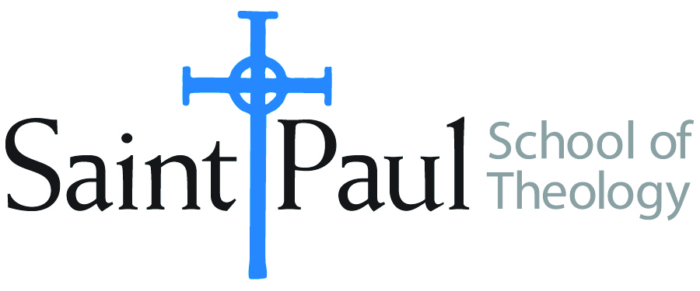
COURSE TEXTBOOK LIST INFORMATION

FACULTY INSTRUCTIONS |  |  | STUDENT INSTRUCTIONS  (Both Campuses)
For each semester taught, faculty should complete and submit a new form each time the course is taught and returned. Forms are due by the first day of registration for a given term.  DESKCOPY – ordered by faculty and adjuncts at a $200 max for 1st time use of text per course. Please fill out an Expense Reimbursement Form, attach all actual/delivered receipts, return via email or mail, and this should be reimbursed with your first stipend payment (or next payroll payment) |  |  | Students may acquire textbooks by ordering online via Amazon or other book retailer and having books shipped to them. Regardless of shopping / ordering method, students may check Cokesbury online for discount on text and certain texts may be sent free delivery.
COURSE INSTRUCTOR(S) | Hal Knight
COURSE NUMBER & SECTION | THL 442 SO, CAM/KS and CAM/OK
COURSE NAME | Contemporary Evangelical Theology
COURSE SEMESTER & YEAR | Spring 2022
DATE OF SUBMISSION | 10-4-21

REQUIRED TEXTBOOKS LIST  BOOK TITLE and EDITION  (include subtitle if applicable) |  | AUTHOR(S) | # of PAGES to be read | PUBLISHER and DATE | 13-Digit ISBN  (without dashes) | LIST PRICE  (est)
1 | The Remaking of Evangelical Theology | Gary Dorrien | 210 | Westminster John Knox 1998 | 9780664258030 | $ 30
2 | Reformed and Always Reforming | Roger E. Olson | 230 | Baker 2007 | 9780801031694 | $ 28
3 | A Future for Truth* | Henry H. Knight III | 190 | Abingdon 1997 | 9780687009602
4 | The Future of Open Theism | Richard Rice | 218 | InterVarsity 2020 | 9780830839384 | $20
5 | Pentecostal Spirituality | Steven Jack Land | 224 | CPT 2010 | 9780981965147 | $ 18
6 | Evangelical Feminism: A History | Pamela D. H. Cochran | 194 | NYU Press 2005 | 9780814716502 | $ 27
7 | Global Theology in Evangelical Perspective | Jeffrey P. Greenman & Gene L. Green, ed. | 244 | InterVarsity 2012 | 9780830839568 | $ 27
 | TOTAL Number of Pages to Be Read |  | 1432

*A copy of this text will be posted on Moodle. Used copies can be found online.

RECOMMENDED TEXTBOOKS LIST

RECOMMENDED TEXTBOOKS LIST  BOOK TITLE and EDITION  (include subtitle if applicable) |  |  | AUTHOR(S) | # of PAGES to be read | PUBLISHER and DATE | 13-Digit ISBN  (without dashes) | LIST PRICE  (est)
1 |  | Rediscovering an Evangelical Heritage | Donald W. Dayton |  | Baker 2014 | 9780801049613
2 |  | From Aldersgate to Azusa Street | Henry H. Knight III, ed. |  | Wipf and Stock, 2010 | 9781606089880
3 |  | Apostles of Reason | Molly Worthen |  | Oxford, 2013 | 9780199896462
4 |  | The Spectrum of Evangelicalism | Andrew David Naselli & Colin Hansen, ds. |  | Zondervan 2011 | 9780310293163
5 |  | Faith Speaking Understanding | Kevin J. Vanhoozer |  | Westminster John Knox, 2014 | 9780664234485

