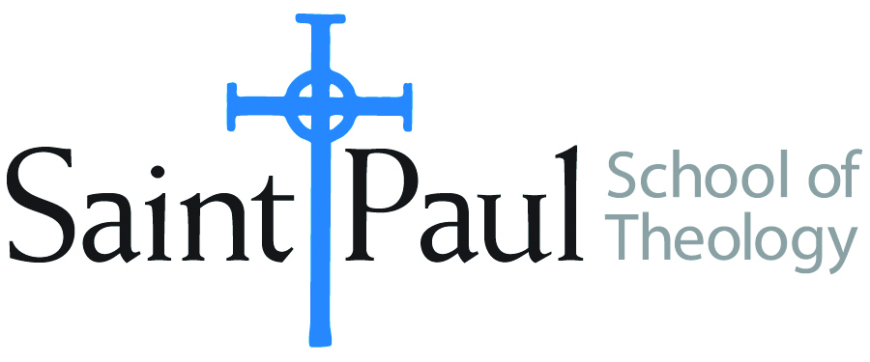
COURSE TEXTBOOK LIST INFORMATION

FACULTY INSTRUCTIONS |  |  | STUDENT INSTRUCTIONS  (Both Campuses)
For each semester taught, faculty should complete and submit a new form each time the course is taught and returned. Forms are due by the first day of registration for a given term.  DESKCOPY – ordered by faculty and adjuncts at a $200 max for 1st time use of text per course. Please fill out an Expense Reimbursement Form, attach all actual/delivered receipts, return via email or mail, and this should be reimbursed with your first stipend payment (or next payroll payment) |  |  | Students may acquire textbooks by ordering online via Amazon or other book retailer and having books shipped to them. Regardless of shopping / ordering method, students may check Cokesbury online for discount on text and certain texts may be sent free delivery.
COURSE INSTRUCTOR(S) | Emanuel Cleaver III
COURSE NUMBER & SECTION | PCM 325
COURSE NAME | Preaching, Politics, and Social Action
COURSE SEMESTER & YEAR | Spring 2022
DATE OF SUBMISSION | 10/13/21

REQUIRED TEXTBOOKS LIST  BOOK TITLE and EDITION  (include subtitle if applicable) |  | AUTHOR(S) | # of PAGES to be read | PUBLISHER and DATE | 13-Digit ISBN  (without dashes) | LIST PRICE  (est)
1 | Where Have All the Prophets Gone?: Reclaiming Prophetic Preaching in America | Marvin McMickle | 160 | Pilgrim Press 10/15/06 | 978-0829817201 | $18
2
3
4
5
6
7
8
9
 | TOTAL Number of Pages to Be Read

RECOMMENDED TEXTBOOKS LIST  BOOK TITLE and EDITION  (include subtitle if applicable) |  |  | AUTHOR(S) | # of PAGES to be read | PUBLISHER and DATE | 13-Digit ISBN  (without dashes) | LIST PRICE  (est)
1
2
3
4
5
6

