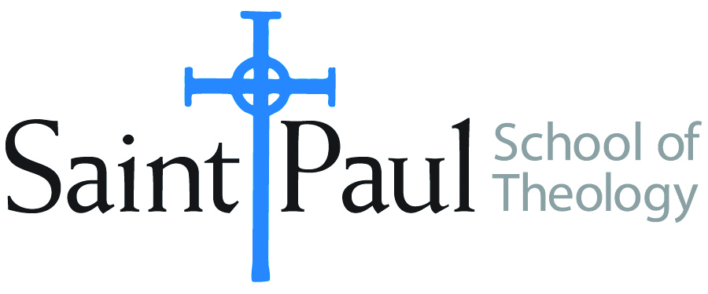
COURSE TEXTBOOK LIST INFORMATION

FACULTY INSTRUCTIONS |  |  | STUDENT INSTRUCTIONS  (Both Campuses)
For each semester taught, faculty should complete and submit a new form each time the course is taught and returned. Forms are due by the first day of registration for a given term.  DESKCOPY – ordered by faculty and adjuncts at a $200 max for 1st time use of text per course. Please fill out an Expense Reimbursement Form, attach all actual/delivered receipts, return via email or mail, and this should be reimbursed with your first stipend payment (or next payroll payment) |  |  | Students may acquire textbooks by ordering online via Amazon or other book retailer and having books shipped to them. Regardless of shopping / ordering method, students may check Cokesbury online for discount on text and certain texts may be sent free delivery.
COURSE INSTRUCTOR(S) | Kris Kvam
COURSE NUMBER & SECTION | MIN 340 and 341:On Campus and Synchronous Online
COURSE NAME | Women, Society, and Church Studies Seminar
COURSE SEMESTER & YEAR | Spring 2022
DATE OF SUBMISSION | October 11, 2021

REQUIRED TEXTBOOKS LIST  BOOK TITLE and EDITION  (include subtitle if applicable) |  | AUTHOR(S) | # of PAGES to be read | PUBLISHER and DATE | 13-Digit ISBN  (without dashes) | LIST PRICE  (est)
1 | Texts of Terror: Literary-Feminist Readings of Biblical Narratives (Overture to Biblical Theology) | Trible, Phyllis | 100-128 | Fortress Press, 197 | 9780800615376 | New: $16.00  Used: $4.00 and up
2 | “Feminist Hermeneutics and Biblical Studies” | Trible, Phyllis | 8 | Religion Online | www.religion-online/article/feminist-hermeneutics-and-biblical
3
4 | TOTAL NUMBER OF PAGES TO BE READ: | ABOUT 110 TO 136
5
6
7 | Recommended TEXTS, CONTINUED FROM NEXT PAGE:  Dinah’s Lament: The Biblical Legacy of Sexual Violence in Christian Interpretation | Schroeder, Joy A. |  | Fortress: 2007 | 978800638436
8 | Womanist Ethics and the Cultural Production of Evil | Townes, emilie m. |  | Palgrave MacMillan, 2006. | 9781403972736
9 | God and the Rhetoric of Sexuality | Trible, Phyllis
 | TOTAL Number of Pages to Be Read

RECOMMENDED TEXTBOOKS LIST  BOOK TITLE and EDITION  (include subtitle if applicable) |  |  | AUTHOR(S) | # of PAGES to be read | PUBLISHER and DATE | 13-Digit ISBN  (without dashes) | LIST PRICE  (est)
1 |  | Violence against Women and Children: A Christian Theological Sourcebook | Adams, Carol J. and Marie M. Fortune, ed. |  | Continuum: 1995 | 9780826408303
2 |  | The Cry of Tamar: Violence against Women and the Church’s Response | Cooper-White, Pamela |  | Fortress: 1995 | 9780800627300
3 |  | A Social Message on Gender-based Violence | Evangelical Lutheran Church in America |  | Adopted 2015. | www.ELCA.org/Faith/Faith-and-Society/Social-Messages
4 |  | Foundational Documentation for a social message on Gender-based Violence | Evangelical Lutheran Church in America |  |  | www.ELCA.org/Faith/Faith-and-Society/Social-Messages
5 |  | NIWRC Advocacy Curriculum | National Indigenous Women’s Resource Center |  | Published July, 2021 | www. Niwrc.org/resources
6 |  | Texts After Terror: Rape, Sexual Violence, and the Hebrew Bible | Graybill, Rhiannon |  | Oxford University Press, 2021 | 9780190082314 | $60.00

Note Well: REcommended Texts Will be discussed in Class along with my reasons for recommending them in the context of this course.

