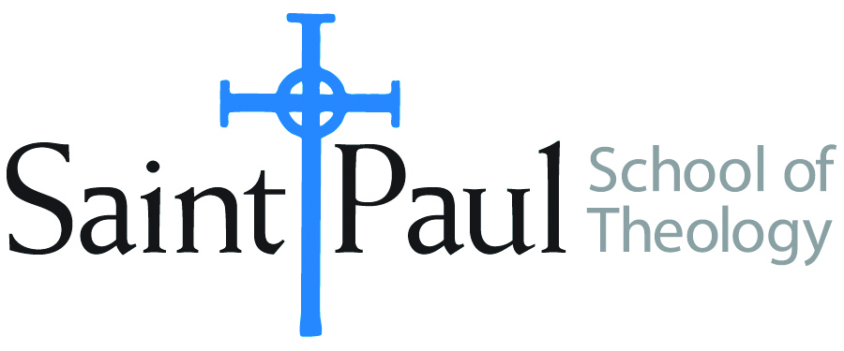
COURSE TEXTBOOK LIST INFORMATION

FACULTY INSTRUCTIONS |  |  | STUDENT INSTRUCTIONS  (Both Campuses)
For each semester taught, faculty should complete and submit a new form for every course and return to Melissa Whalen in the Academic Life office. Forms are due by the first day of registration for a given term. Desk copies for Teaching Assistants must be requested on this form. It is up to the publishers’ discretion whether or not to provide desk copies for teaching assistants. |  |  | Students may acquire textbooks by ordering online or directly from the publisher, which in some cases, the prices are more economical. Regardless of shopping/ordering method, students may check Cokesbury online for discount on text, or follow recommendations by your professor.
COURSE INSTRUCTOR(S) | Robinson
COURSE NUMBER & SECTION | DST 320 ON
COURSE NAME | United Methodist History
COURSE SEMESTER &YEAR | Spring 2022
DATE OF SUBMISSION | October 8. 2022

REQUIRED TEXTBOOKS LIST
BOOK TITLE and EDITION  (include subtitle if applicable) |  | AUTHOR(S) | No. of  PAGES to be read | PUBLISHER and DATE | 13-Digit ISBN  (without dashes) | LIST PRICE  (estimate) | DESK COPY
1 | American Methodism: A Compact History | Richey, Rowe, and Schmidt | 200 | Abingdon, 2012 | 9781426742279 | $25
2 | Wesley and the People Called Methodists, second edition | Richard P. Heitzenrater | 250 | Abingdon, 2013 | 9781426742248 | $25
3 | We Shall Not Be Moved | Nickell, Jane Ellen | 100 | Pickwick, 2014 | 9781625644848 | $25
4
5
6
7
 | TOTAL Number of Pages to Be Read |  | 550

RECOMMENDED TEXTBOOKS LIST
BOOK TITLE and EDITION  (include subtitle if applicable) |  | AUTHOR(S) | No. of  PAGES to be read | PUBLISHER and DATE | 13-Digit ISBN  (without dashes) | LIST PRICE  (estimate) | DESK COPY
1
2
3
4

Special Instructions to Cokesbury:

