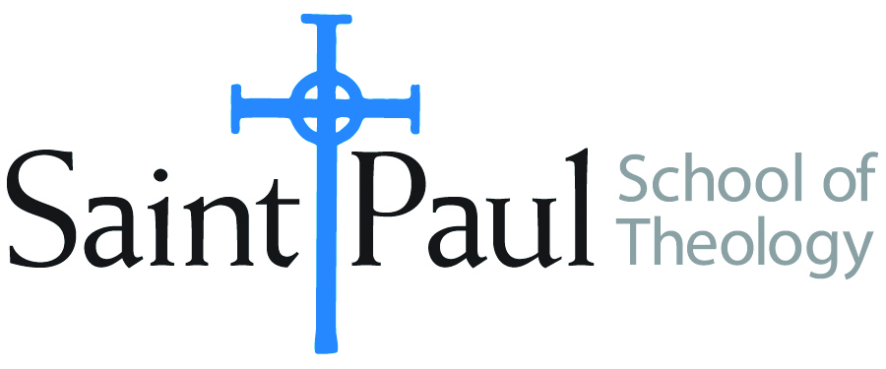
COURSE TEXTBOOK LIST INFORMATION

FACULTY INSTRUCTIONS |  |  | STUDENT INSTRUCTIONS  (Both Campuses)
For each semester taught, faculty should complete and submit a new form each time the course is taught and returned. Forms are due by the first day of registration for a given term.  DESKCOPY – ordered by faculty and adjuncts at a $200 max for 1st time use of text per course. Please fill out an Expense Reimbursement Form, attach all actual/delivered receipts, return via email or mail, and this should be reimbursed with your first stipend payment (or next payroll payment) |  |  | Students may acquire textbooks by ordering online via Amazon or other book retailer and having books shipped to them. Regardless of shopping / ordering method, students may check Cokesbury online for discount on text and certain texts may be sent free delivery.
COURSE INSTRUCTOR(S) | Hal Knight
COURSE NUMBER & SECTION | CHS 323 SO
COURSE NAME | The Church in a Divided America
COURSE SEMESTER & YEAR | Spring 2022
DATE OF SUBMISSION | 10-4-21

REQUIRED TEXTBOOKS LIST  BOOK TITLE and EDITION  (include subtitle if applicable) |  | AUTHOR(S) | # of PAGES to be read | PUBLISHER and DATE | 13-Digit ISBN  (without dashes) | LIST PRICE  (est)
1 | Political Tribes | Amy Chua | 210 | Penguin 2018 | 9780399562877 | $13
2 | Last Best Hope | George Packer | 217 | Farrar, Straus & Giroux 2021 | 9780374603663 | $17
3 | Is There a Future for God’s Love? | Henry H. Knight III | 164 | Abingdon 2012 | 9780687660339 | $17
 | TOTAL Number of Pages to Be Read |  | 591

RECOMMENDED TEXTBOOKS LIST  BOOK TITLE and EDITION  (include subtitle if applicable) |  | AUTHOR(S) | # of PAGES to be read | PUBLISHER and DATE | 13-Digit ISBN  (without dashes) | LIST PRICE  (est)
1 | The Church of Us vs. Them | Davd E. Fitch |  | Brazos 2019 | 9781587434143

