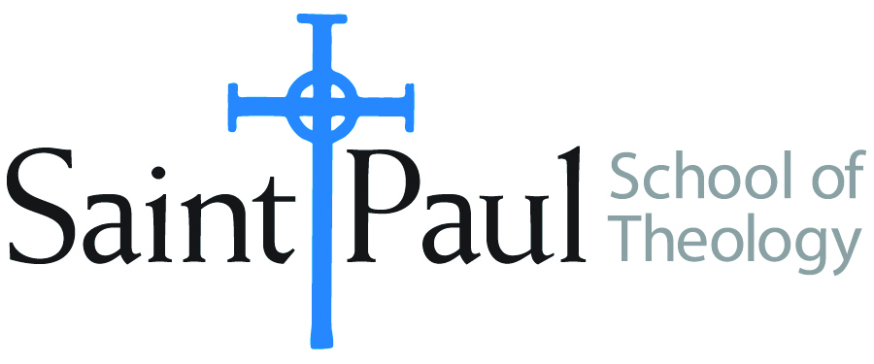
COURSE TEXTBOOK LIST INFORMATION

FACULTY INSTRUCTIONS |  |  | STUDENT INSTRUCTIONS  (Both Campuses)
For each semester taught, faculty should complete and submit a new form for every course and return to . Forms are due by the first day of registration for a given term. Desk copies for Teaching Assistants must be requested on this form. It is up to the publishers’ discretion whether or not to provide desk copies for teaching assistants. |  |  | Students may acquire textbooks by ordering online via Amazon Associate on our website and having books shipped to them. Regardless of shopping/ordering method, students may check Cokesbury online for discount on text and certain text may be sent free delivery.
COURSE INSTRUCTOR(S) | Elaine Robinson
COURSE NUMBER & SECTION | CHL 313 CAM/KS CAM/OK SO
COURSE NAME | Spiritual Leadership
COURSE SEMESTER &YEAR | Spring 2022
DATE OF SUBMISSION | October 8, 2021

REQUIRED TEXTBOOKS LIST
BOOK TITLE and EDITION  (include subtitle if applicable) |  | AUTHOR(S) | No. of  PAGES to be read | PUBLISHER and DATE | 13-Digit ISBN  (without dashes) | LIST PRICE  (estimate) | DESK COPY
1 | Leading the Congregation, Revised Edition | Heuser, Roger and Norman Shawchuck | 200 | Abingdon Press, 2010 | 9781426711398 | $18
2 | Faith After Doubt | McLaren, Brian | 200 | New York: St. Martin's, 2021 | 9781250828378 | $18
3 | The Naked Now | Rohr, Richard | 170 | Crossroad Publishing, 2009 | 9780824525439 | $11
4 | A Strange Freedom: The Best of Howard Thurman on Religious Experience and Public Life | Edited by Walter Earl Fluker and Catherine Tumber | 150 | Beacon Press, 1998 | 9780807010570 | $25
5
6
7
 | TOTAL Number of Pages to Be Read |  | 520

RECOMMENDED TEXTBOOKS LIST
BOOK TITLE and EDITION  (include subtitle if applicable) |  | AUTHOR(S) | No. of  PAGES to be read | PUBLISHER and DATE | 13-Digit ISBN  (without dashes) | LIST PRICE  (estimate) | DESK COPY
1
2
3
4

Special Instructions to Cokesbury:

