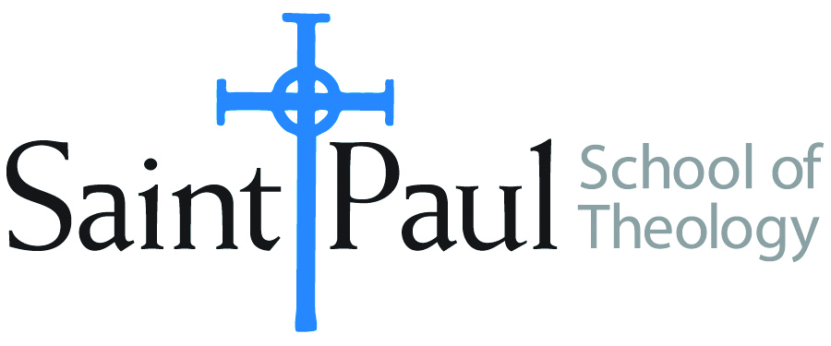
COURSE TEXTBOOK LIST INFORMATION

FACULTY INSTRUCTIONS |  |  | STUDENT INSTRUCTIONS  (Both Campuses)
For each semester taught, faculty should complete and submit a new form each time the course is taught and returned. Forms are due by the first day of registration for a given term.  DESKCOPY – ordered by faculty and adjuncts at a $200 max for 1st time use of text per course. Please fill out an Expense Reimbursement Form, attach all actual/delivered receipts, return via email or mail, and this should be reimbursed with your first stipend payment (or next payroll payment) |  |  | Students may acquire textbooks by ordering online via Amazon or other book retailer and having books shipped to them. Regardless of shopping / ordering method, students may check Cokesbury online for discount on text and certain texts may be sent free delivery.
COURSE INSTRUCTOR(S) | Nancy R. Howell
COURSE NUMBER & SECTION | ASR 420 HYB
COURSE NAME | Summative Seminar
COURSE SEMESTER & YEAR | Spring 2022
DATE OF SUBMISSION | 10/2/21

REQUIRED TEXTBOOKS LIST  BOOK TITLE and EDITION  (include subtitle if applicable) |  | AUTHOR(S) | # of PAGES to be read | PUBLISHER and DATE | 13-Digit ISBN  (without dashes) | LIST PRICE  (est)
1 | Trails of Hope and Terror | Miguel A. De la Torre | 224 | Orbis Books 2009 | 9781570757983 | $20
2 | God and the Illegal Alien: United States Immigration and a Theology of Politics | Robert W. Heimburger | 260 | Cambridge University Press  2018 | 9781316629833 | $20
3 | No Strangers Here: Christian Hospitality and Refugee Ministry in Twenty-first Century Hong Kong | Judy Chan | 2340 | Pickwick Publications  2017 | 9281532604157 | $29
4 | Christian Hospitality and Muslim Immigration in an Age of Fear | Matthew Kaemingk | 296 | Eerdmans  2018 | 9780802874580 | $28
5
6
7
8
9
 | TOTAL Number of Pages to Be Read |  | 1018

RECOMMENDED TEXTBOOKS LIST  BOOK TITLE and EDITION  (include subtitle if applicable) |  |  | AUTHOR(S) | # of PAGES to be read | PUBLISHER and DATE | 13-Digit ISBN  (without dashes) | LIST PRICE  (est)
1 |  | A Manual of Style for Writers of Research Papers, Theses, and Dissertations | Kate L. Turabian | n/a | University of Chicago Press  2018 | 9780226430577 | $15
2
3
4
5
6
 |  |  |  | n/a

