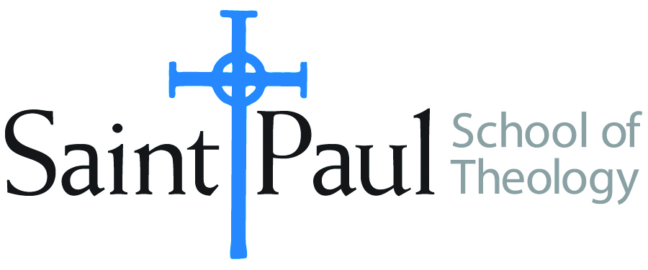
COURSE TEXTBOOK LIST INFORMATION

FACULTY INSTRUCTIONS |  |  | STUDENT INSTRUCTIONS  (Both Campuses)
For each semester taught, faculty should complete and submit a new form each time the course is taught and returned. Forms are due by the first day of registration for a given term.  DESKCOPY – ordered by faculty and adjuncts at a $200 max for 1st time use of text per course. Please fill out an Expense Reimbursement Form, attach all actual/delivered receipts, return via email or mail, and this should be reimbursed with your first stipend payment (or next payroll payment) |  |  | Students may acquire textbooks by ordering online via Amazon or other book retailer and having books shipped to them. Regardless of shopping / ordering method, students may check Cokesbury online for discount on text and certain texts may be sent free delivery.
COURSE INSTRUCTOR(S) | Richard Liantonio
COURSE NUMBER & SECTION | HBS 320
COURSE NAME | Introduction to Biblical Hebrew
COURSE SEMESTER & YEAR | Fall 2021
DATE OF SUBMISSION

REQUIRED TEXTBOOKS LIST  BOOK TITLE and EDITION  (include subtitle if applicable) |  | AUTHOR(S) | # of PAGES to be read | PUBLISHER and DATE | 13-Digit ISBN  (without dashes) | LIST PRICE  (est)
1 | Beginning Biblical Hebrew: A Grammar and Illustrated Reader | John A. Cook and Robert D. Holmstedt | 139+90 | Baker | 9780801048869 | $41.87
2 | Learn Biblical Hebrew, Second Edition | John H. Dobson | 300 | Baker | 9780801097423 | $36.00
3 | Biblical Hebrew Laminated Sheet (Zondervan Get an A! Study Guides) | Gary D. Pratico, Miles V. Van Pelt | 4 | Zondervan Academic | 9780310262954 | $11.99
4 | Biblia Hebraica Stuttgartensia: A Reader's Edition (Hebrew Edition) | Donald A. Vance, George Athas | x | Hendrickson | 9781598563429 or 9781598567496 | $55.95
5 | Aleph With Beth | Bethany and Jonathan Case |  | https://youtu.be/y640-FIpxQs | NA | Free
6
7
8
9
 | TOTAL Number of Pages to Be Read

RECOMMENDED TEXTBOOKS LIST  BOOK TITLE and EDITION  (include subtitle if applicable) |  |  | AUTHOR(S) | # of PAGES to be read | PUBLISHER and DATE | 13-Digit ISBN  (without dashes) | LIST PRICE  (est)
1 |  | A Biblical Hebrew Reference Grammar: Second Edition | Christo H. van der Merwe, Jacobus A. Naudé |  | T&T Clark | 9780567663337 | 49.95
2
3
4
5
6

