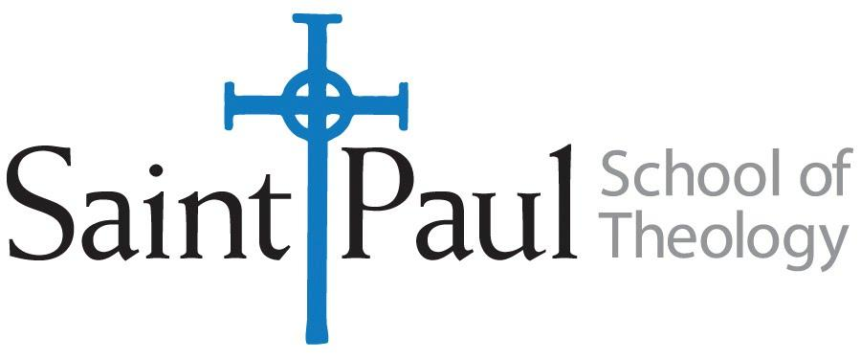
COURSE TEXTBOOK LIST INFORMATION

FACULTY INSTRUCTIONS |  |  | STUDENT INSTRUCTIONS  (Both Campuses)
For each semester taught, faculty should complete and submit a new form each time the course is taught and returned. Forms are due by the first day of registration for a given term.  DESKCOPY – ordered by faculty and adjuncts at a $200 max for 1st time use of text per course. Please fill out an Expense Reimbursement Form, attach all actual/delivered receipts, return via email or mail, and this should be reimbursed with your first stipend payment (or next payroll payment) |  |  | Students may acquire textbooks by ordering online via Amazon or other book retailer and having books shipped to them. Regardless of shopping / ordering method, students may check Cokesbury online for discount on text and certain texts may be sent free delivery.
COURSE INSTRUCTOR(S) | Rev. Dr. Katie Nix
COURSE NUMBER & SECTION | CHS 330
COURSE NAME | Mission of the Church in the Contemporary World
COURSE SEMESTER & YEAR | Fall 2021 and Spring 2022
DATE OF SUBMISSION | July 12, 2021

REQUIRED TEXTBOOKS LIST  BOOK TITLE and EDITION  (include subtitle if applicable) |  | AUTHOR(S) | # of PAGES to be read | PUBLISHER and DATE | 13-Digit ISBN  (without dashes) | LIST PRICE  (est)
1 | When Helping Hurts: How to Alleviate Poverty Without Hurting the Poor…and Yourself. | Corbett, Steve and Brian Fikkert | 200 | Chicago: Moody Publishers, 2012
2 | Churches, Cultures, and Leadership | Branson, Mark and Juan Martínez | 94 | Downers Grove, IL: InterVarsity Press, 2011
3 | I’m Still Here: Black Dignity in a World Made for Whiteness | Brown, Austin Channing |  | Convergent Books, 2018
4 | InterGenerate: Transforming Churches through Intergenerational Ministry | Allen, Holly Catterton ed | 45 | Abilene Christian University Press, 2018
5 | Deep Justice in a Broken World | Powell, Kara and Chap Clark | 250 | Grand Rapids, MI:Zondervan, 2007.
 | TOTAL Number of Pages to Be Read

RECOMMENDED TEXTBOOKS LIST  BOOK TITLE and EDITION  (include subtitle if applicable) |  |  | AUTHOR(S) | # of PAGES to be read | PUBLISHER and DATE | 13-Digit ISBN  (without dashes) | LIST PRICE  (est)
1 |  | The Dangerous Act of Worship | Labberton, Mark | 150 | Downers Grove, IL: InterVarsity Press, 2007.
2 |  | Be My Witnesses | Guder, Darrell | 150 | William B. Eerdmans Publishing  Company, 1985.
3 |  | The Open Secret: An Introduction to the Theology of Mission | Newbigin, Lesslie | 150 | Grand Rapids, MI: William B. Eerdmans Publishing Company, 1995.
4 |  | Faithful Presence: Seven Disciplines That Shape the Church for Mission | Fitch, David. | 150 | Downers Grove, IL: InterVarsity Press, 2016.

