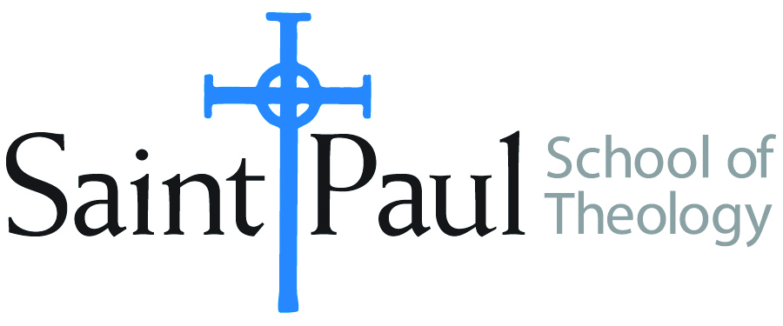
COURSE TEXTBOOK LIST INFORMATION

FACULTY INSTRUCTIONS |  |  | STUDENT INSTRUCTIONS  (Both Campuses)
For each semester taught, faculty should complete and submit a new form each time the course is taught and returned. Forms are due by the first day of registration for a given term.  DESKCOPY – ordered by faculty and adjuncts at a $200 max for 1st time use of text per course. Please fill out an Expense Reimbursement Form, attach all actual/delivered receipts, return via email or mail, and this should be reimbursed with your first stipend payment (or next payroll payment) |  |  | Students may acquire textbooks by ordering online via Amazon or other book retailer and having books shipped to them. Regardless of shopping / ordering method, students may check Cokesbury online for discount on text and certain texts may be sent free delivery.
COURSE INSTRUCTOR(S) | Kris Kvam
COURSE NUMBER & SECTION | THL 450 ON
COURSE NAME | Selected Theologian: Serene Jones
COURSE SEMESTER & YEAR | Fall 2021
DATE OF SUBMISSION | March 5, 2021

REQUIRED TEXTBOOKS LIST  BOOK TITLE and EDITION  (include subtitle if applicable) |  | AUTHOR(S) | # of PAGES to be read | PUBLISHER and DATE | 13-Digit ISBN  (without dashes) | LIST PRICE  (est)
1 | Feminist Theory and Christian Theology: Cartographies of Grace | Jones, Serene | 205 | Fortress, 2000 | 9780800626945
2 | Trauma and Grace: Theology in a Ruptured World | Jones, Serene | 175 | Westminster John Knox, 2009 | 9780664234102
3 | Call It Grace: Finding Meaning in a Fractured World | Jones, Serene | 308 | Viking, 2019. | 9780735223646
4
 | TOTAL Number of Pages to Be Read |  | 700, plus articles & research

RECOMMENDED TEXTBOOKS LIST  BOOK TITLE and EDITION  (include subtitle if applicable) |  |  | AUTHOR(S) | # of PAGES to be read | PUBLISHER and DATE | 13-Digit ISBN  (without dashes) | LIST PRICE  (est)
1 |  | Dictionary of Feminist Theologies | Russell and Clarkson, eds. |  | Westminster John Knox, 1996 | 9780664229238
2 |  | Additional Recommendations will be announced later
3
4
5
6

