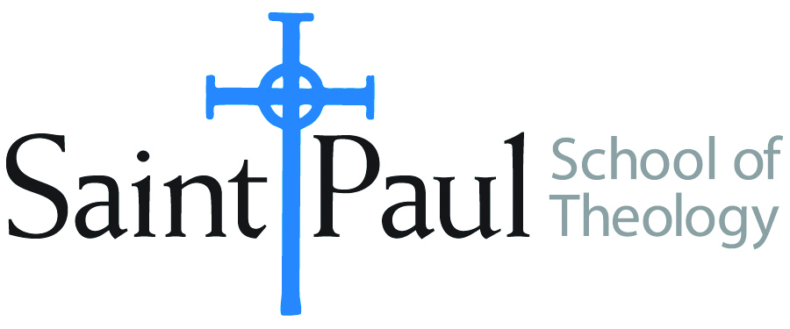
COURSE TEXTBOOK LIST INFORMATION

FACULTY INSTRUCTIONS |  |  | STUDENT INSTRUCTIONS  (Both Campuses)
For each semester taught, faculty should complete and submit a new form each time the course is taught and returned. Forms are due by the first day of registration for a given term.  DESKCOPY – ordered by faculty and adjuncts at a $200 max for 1st time use of text per course. Please fill out an Expense Reimbursement Form, attach all actual/delivered receipts, return via email or mail, and this should be reimbursed with your first stipend payment (or next payroll payment) |  |  | Students may acquire textbooks by ordering online via Amazon or other book retailer and having books shipped to them. Regardless of shopping / ordering method, students may check Cokesbury online for discount on text and certain texts may be sent free delivery.
COURSE INSTRUCTOR(S) | Melissa Tubbs Loya
COURSE NUMBER & SECTION | HBS 434 HYB
COURSE NAME | The Book of Exodus
COURSE SEMESTER & YEAR | Summer 2021
DATE OF SUBMISSION | 3.16.21

REQUIRED TEXTBOOKS LIST  BOOK TITLE and EDITION  (include subtitle if applicable) |  | AUTHOR(S) | # of PAGES to be read | PUBLISHER and DATE | 13-Digit ISBN  (without dashes) | LIST PRICE  (est)
1 | EITHER The HarperCollins Study Bible: Fully Revised & Updated (NRSV)* | Attridge, H., ed. | selections | HarperOne, 2006 | 9780061228407 | b/w $25–45 on Amazon
2 | OR The New Oxford Annotated Bible with the Apocrypha, New Revised Standard Version, 5th College Ed.* | Coogan, M. D., ed. | selections | Oxford University Press, 2018 | 9780190276072 | b/w $25–45 on Amazon
3 | Exodus (New Cambridge Bible Commentary) | Carol Meyers | 330 | Cambridge University Press, 2005 | 9780521002912 | $33 on Amazon
4 | Exodus (Interpretation: A Bible Commentary for Teaching and Preaching) | Terrance E. Fretheim | 330 | Westminster John Knox Press, 2010 | 9780664236199 | $25 on Amazon
5 | Exploring Exodus: The Origins of Biblical Israel | Nahum M. Sarna | 270 | Schocken, 1996 | 9780805210637 | $17 on Amazon
6
7
8
 | TOTAL Number of Pages to Be Read |  | 930** | **plus required biblical passages and optional supplemental readings; links to be put on Moodle

RECOMMENDED TEXTBOOKS LIST  BOOK TITLE and EDITION  (include subtitle if applicable) |  |  | AUTHOR(S) | # of PAGES to be read | PUBLISHER and DATE | 13-Digit ISBN  (without dashes) | LIST PRICE  (est)
1
2
3
4
5
6

